15-04-2024

Hands on by Raj Sir -----LMS VPC Assignment

Module 5: Case Study - 1

Problem Statement:

You work for XYZ Corporation and based on the expansion requirements of your

corporation you have been asked to create and set up a distinct Amazon VPC for

the production and development team. You are expected to perform the following

tasks for the respective VPCs.

**Production Network:**

1. Design and build a 4-tier architecture.

2. Create 5 subnets out of which 4 should be private named app1, app2,

dbcache and db and one should be public, named web.

3. Launch instances in all subnets and name them as per the subnet that

they have been launched in.

4. Allow dbcache instance and app1 subnet to send internet requests.

5. Manage security groups works on EC2 and it only allows traffic Level and NACLs works on subnet level and it allows and deny traffic.

**Development Network:**

1. Design and build 2-tier architecture with two subnets named web and db

and launch instances in both subnets and name them as per the subnet

names.

2. Make sure only the web subnet can send internet requests.

3. Create peering connection between production network and development

network.

4. Setup connection between db subnets of both production network and

development network respectively.

1. **Design and build a 4-tier architecture.**

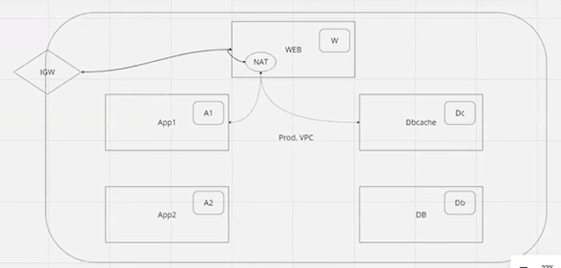

**Now Go to AWS Console and Create VPC in London Region**

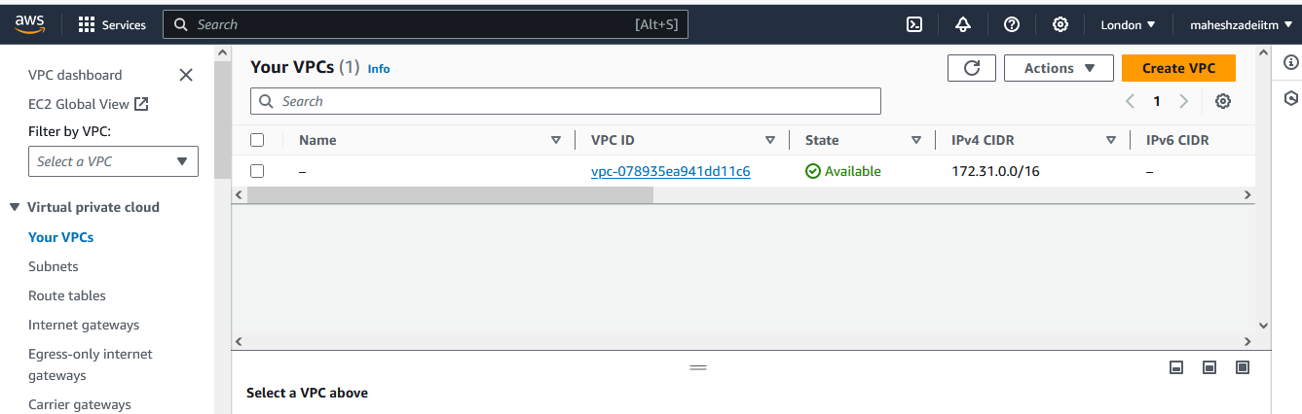

**Give CIDR as 10.0.0.0/16**

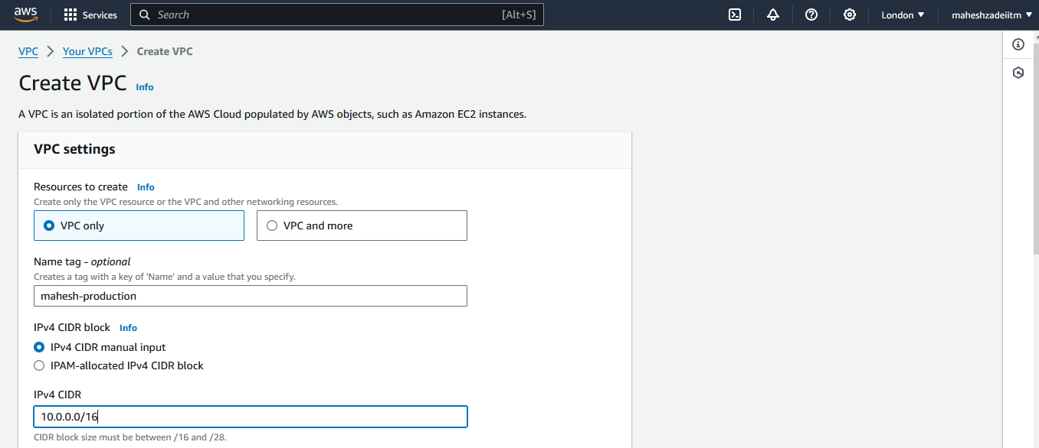

**Calculate CIDR for 5 subnets as required in the assignments**

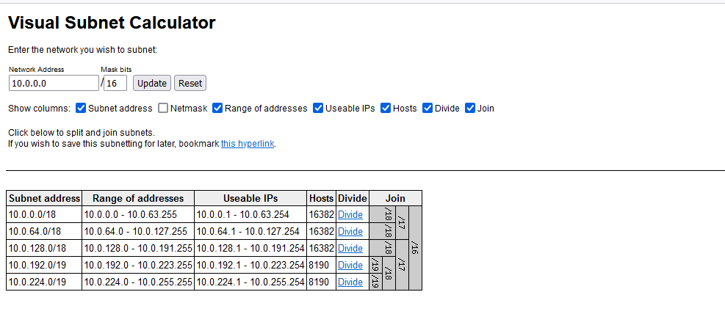

**Click on Create VPC**

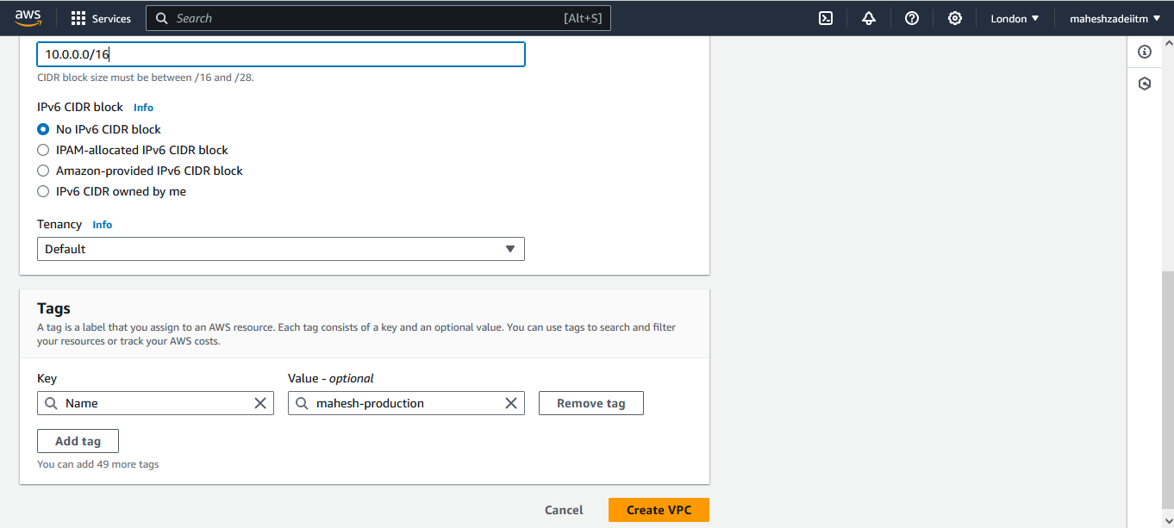

**VPC Created in Production**

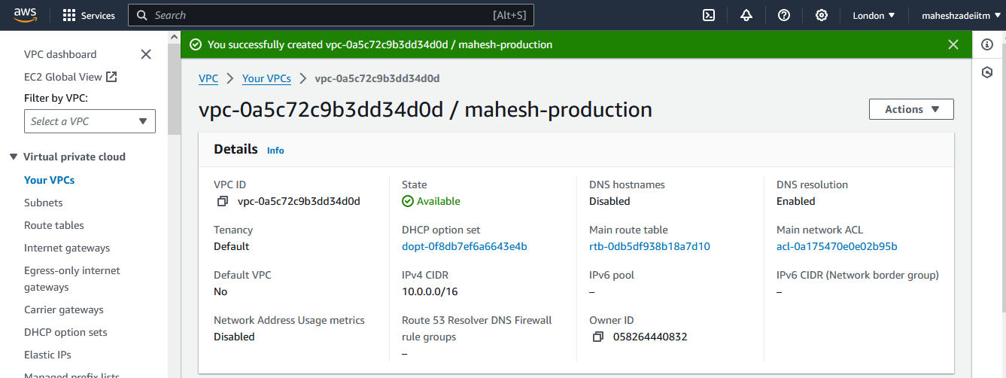

**Now Go to subnet and create the five subnet as mentioned in the assignments**

2. Create 5 subnets out of which 4 should be private named app1, app2,

dbcache and db and one should be public, named web.

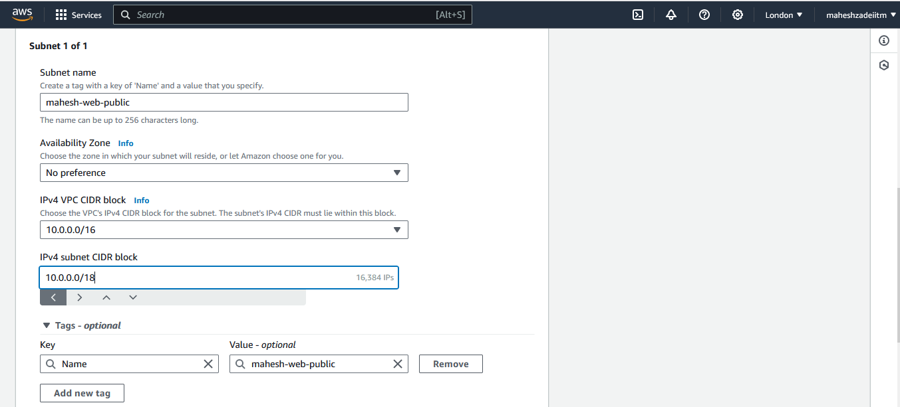

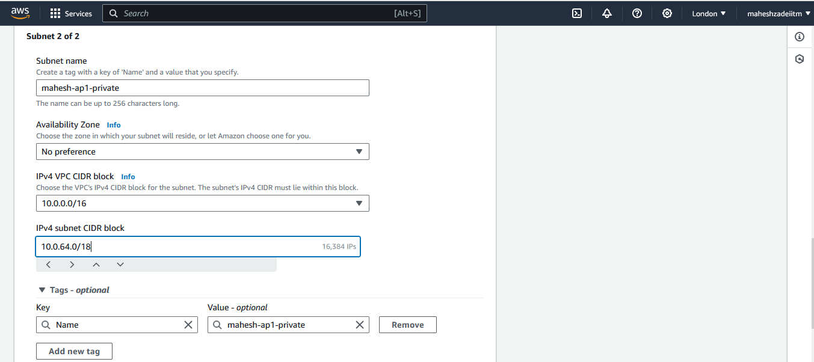

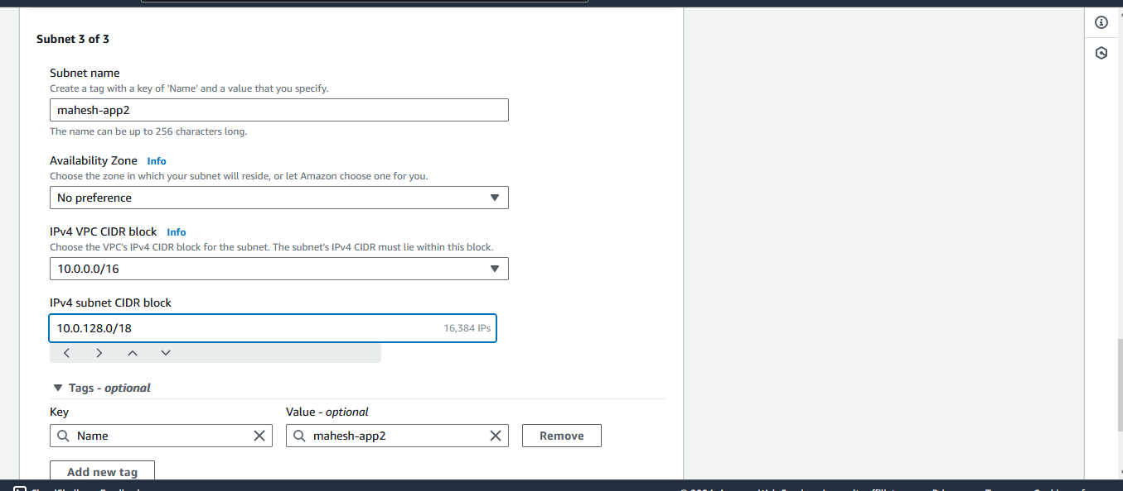

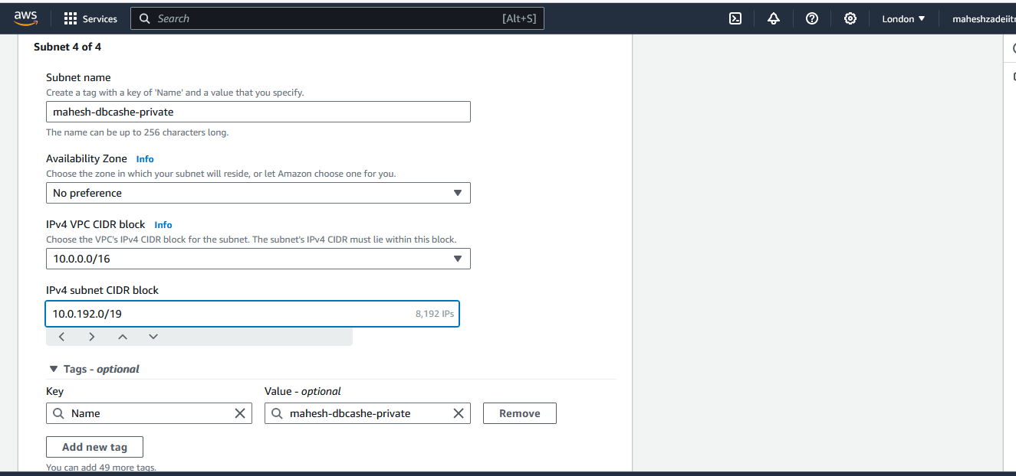

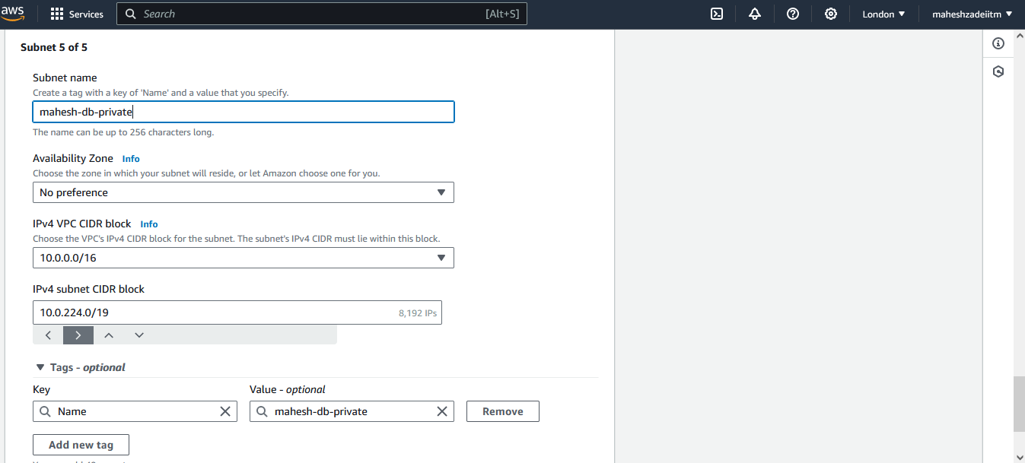

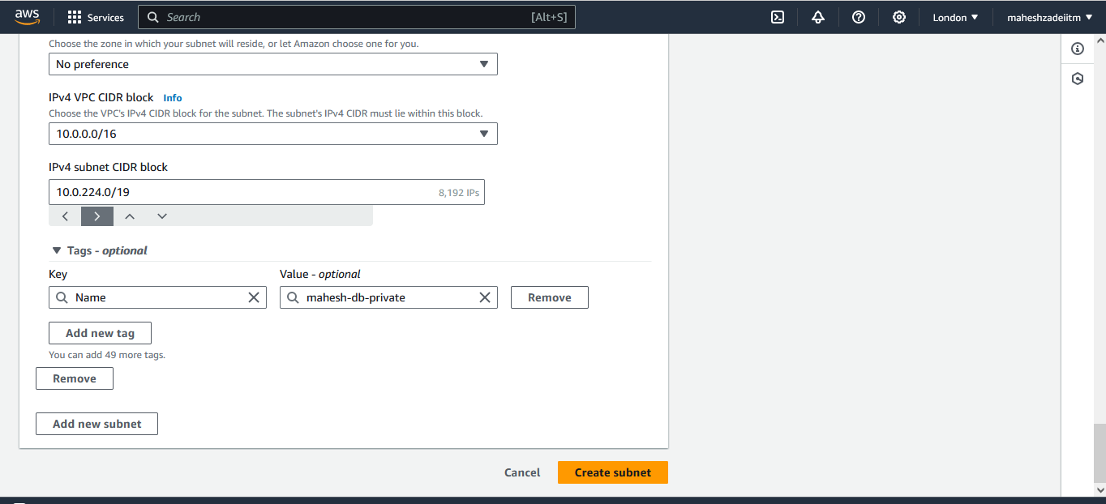

**5 Subnets created**

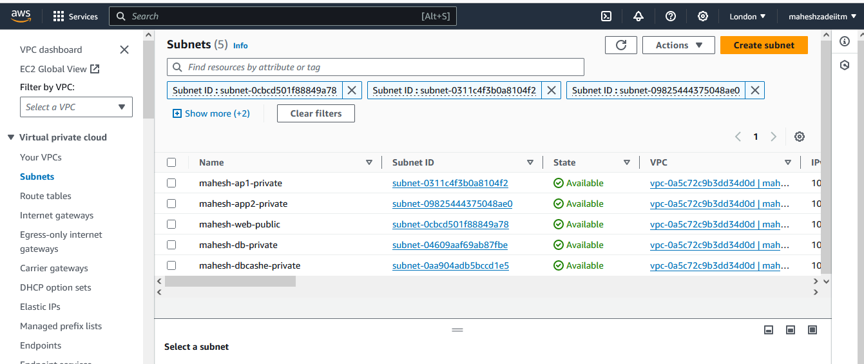

**Now Go to Internet Gateway**

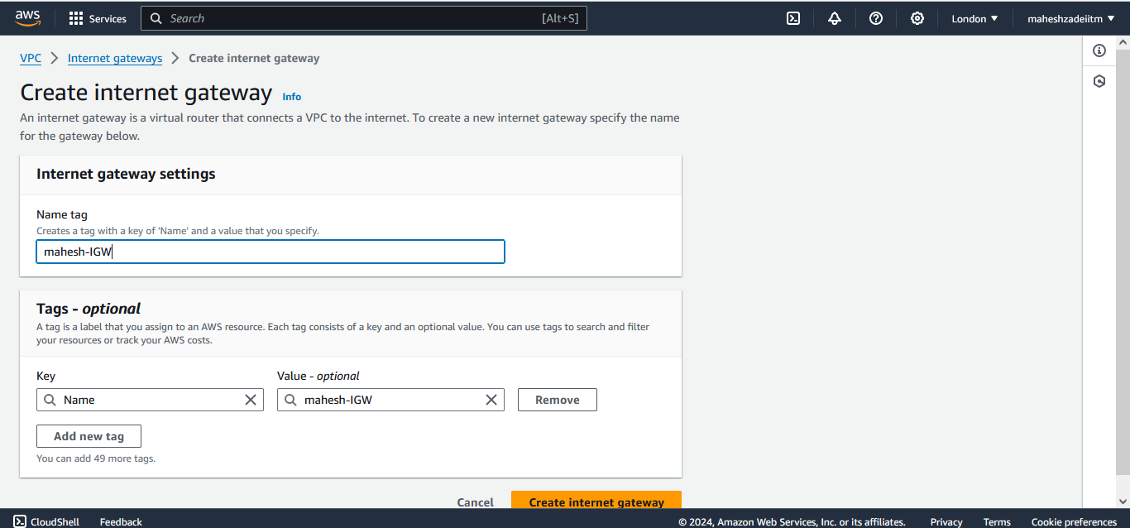

**Now attach it to VPC**

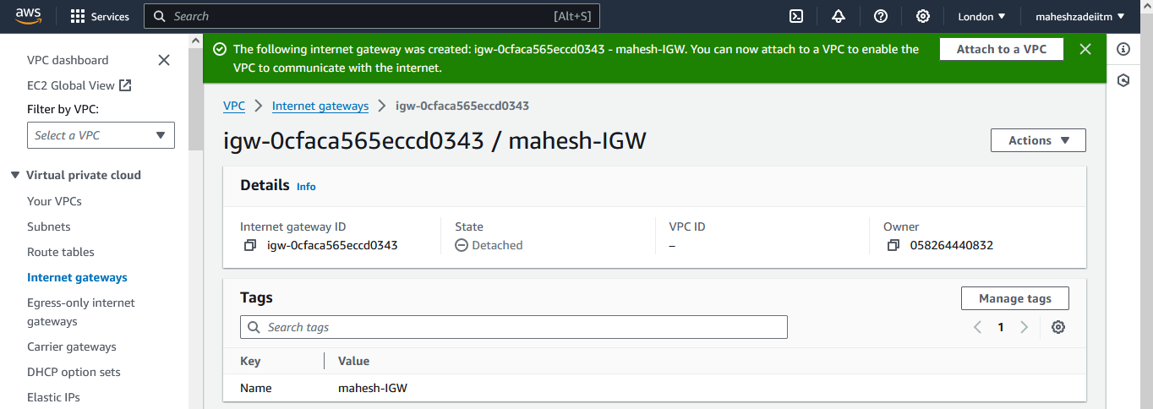

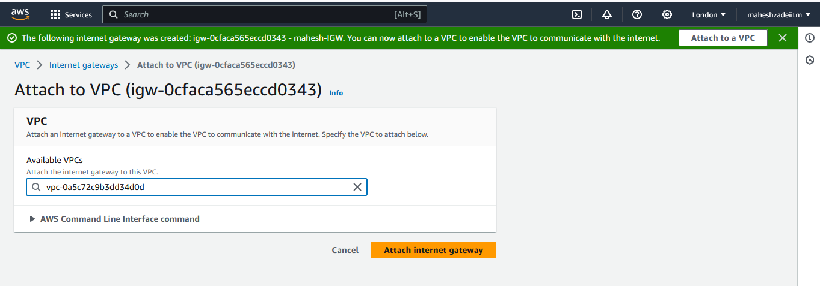

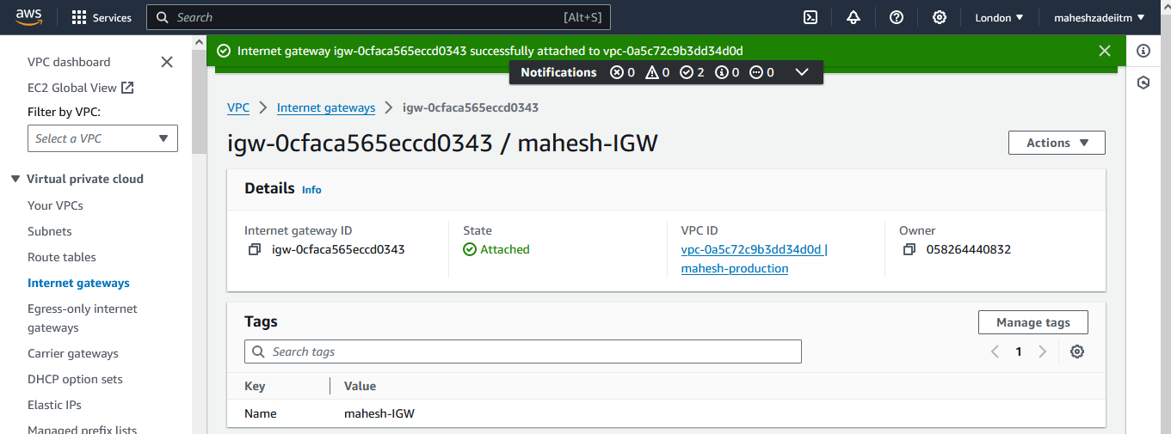

**Now go to VPC to Check Resource MAP any subnet is associated to Route Table**

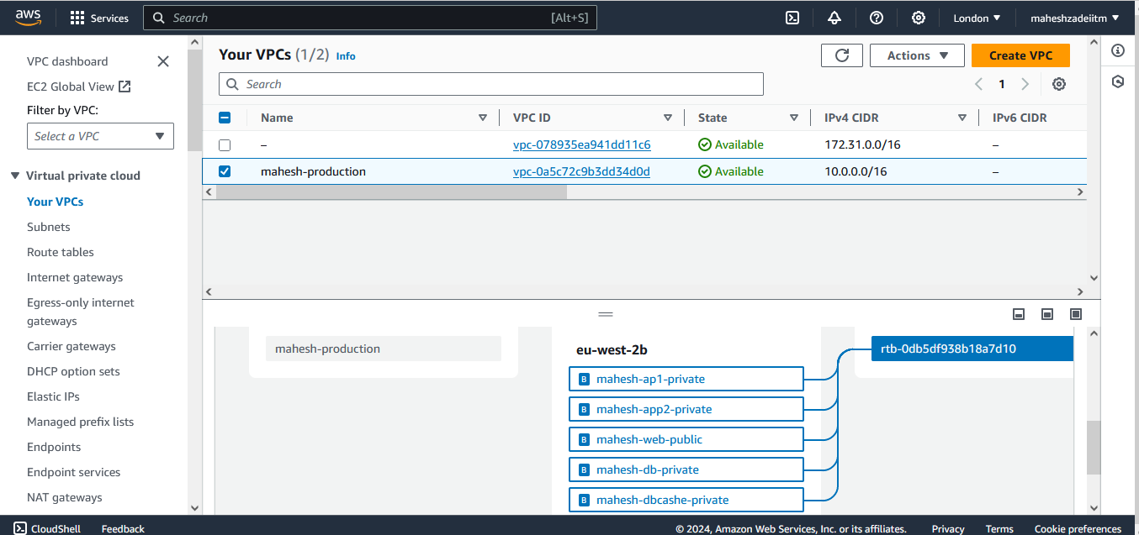

**Now go to Route Table and create 3 Route Table for web , 1 for NAT subnets , and 1 db subnets**

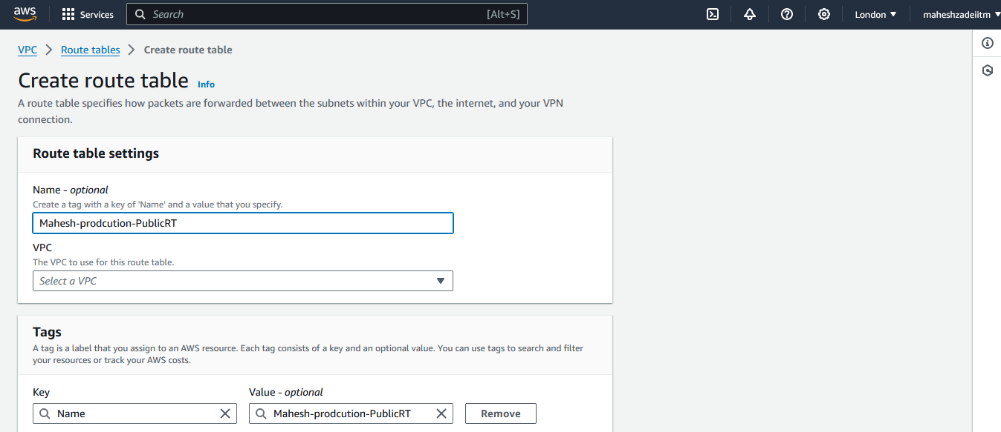

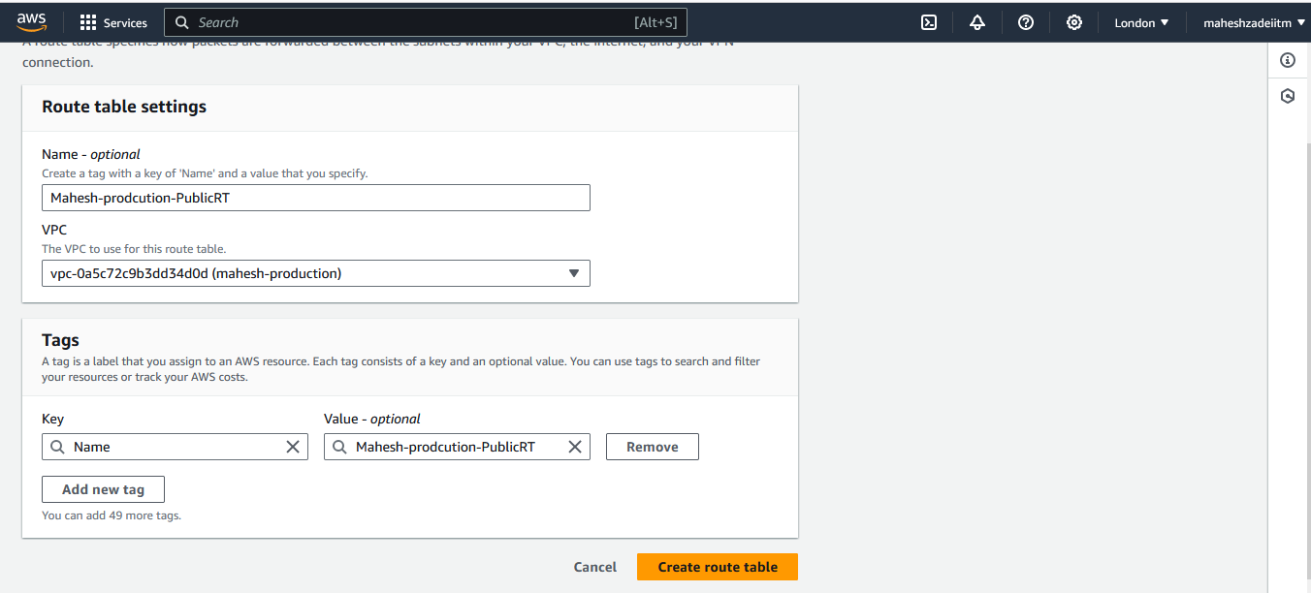

**Edit sunet association for the public RT**

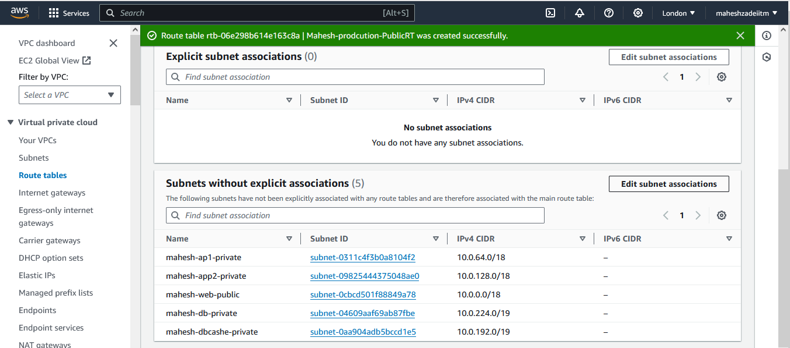

**And save association**

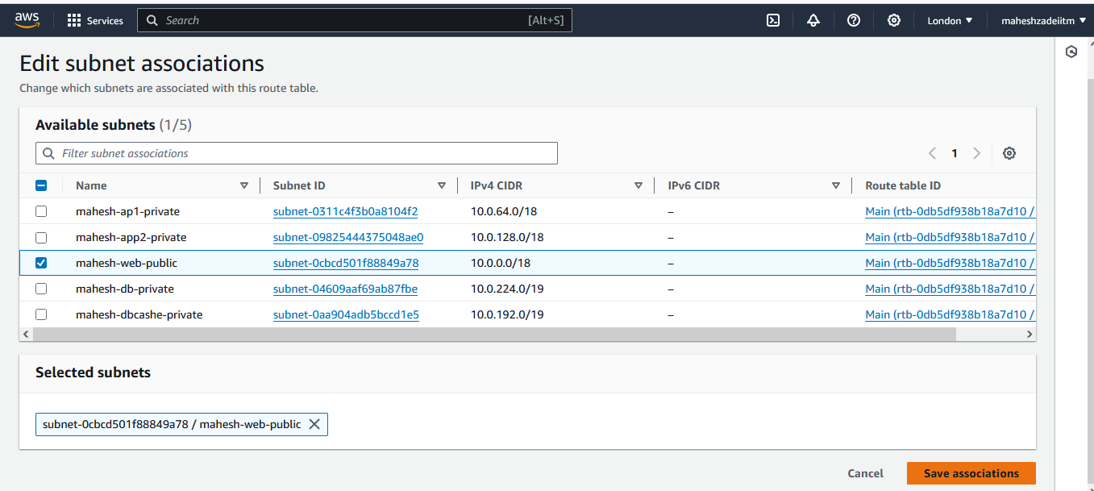

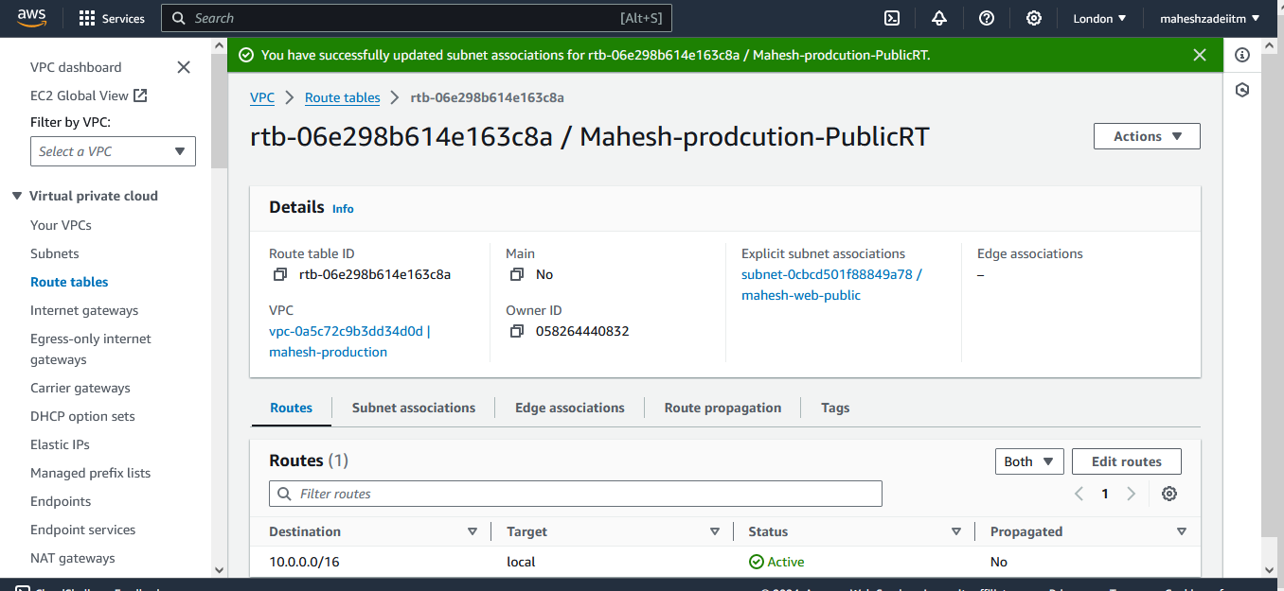

**Now we can see in subnet association public RT associated**

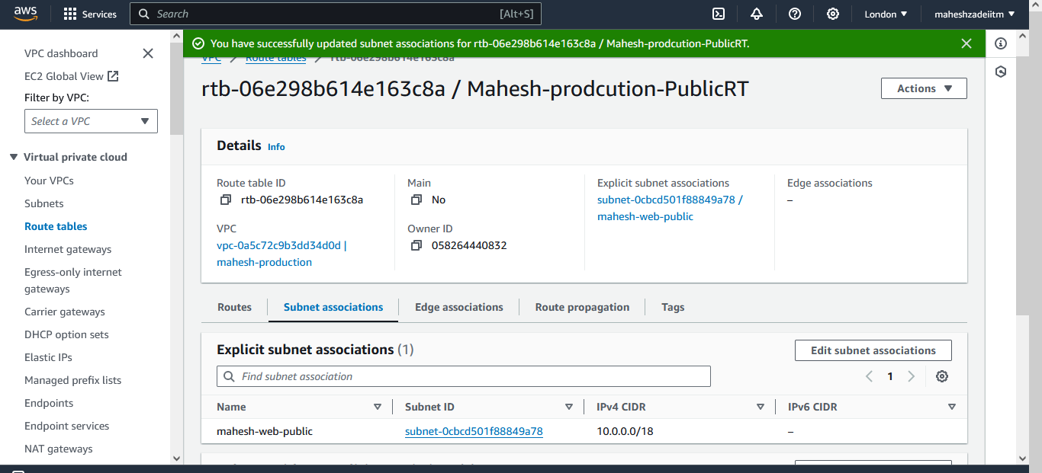

**Now you can check un VPC resource MAP**

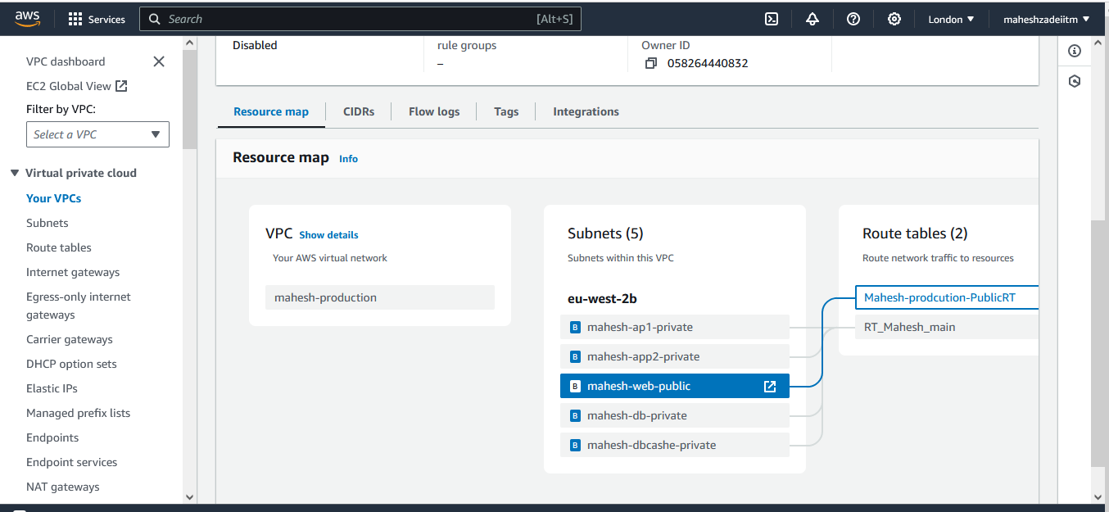

**We need to give internet connectivity here**

**Go to RT -edit public RT**

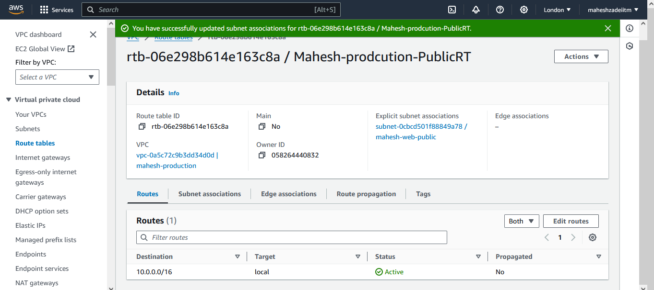

**Add route and select internet gateway And save changes**

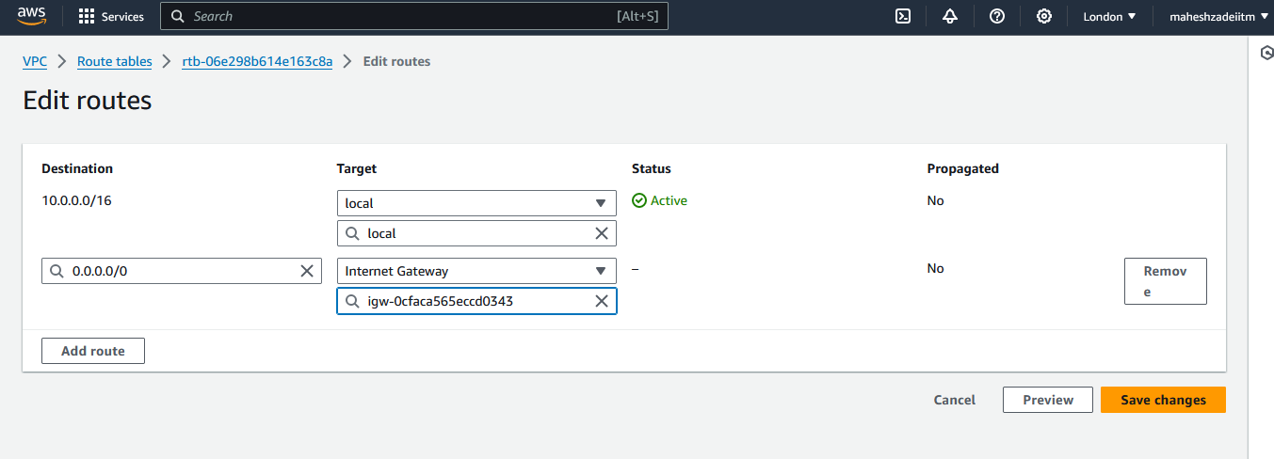

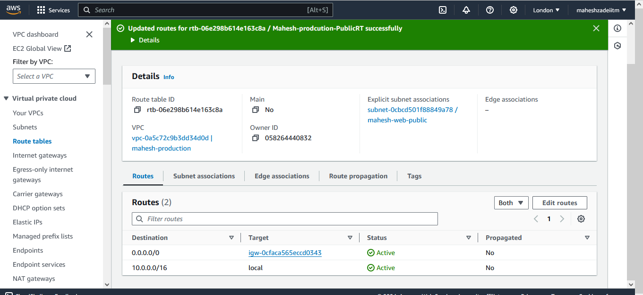

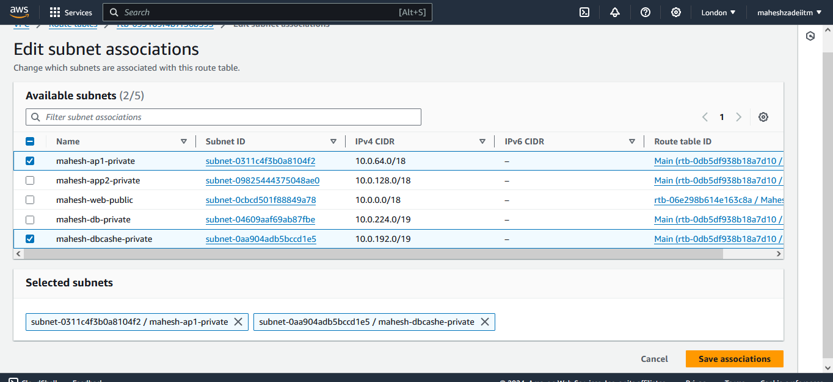

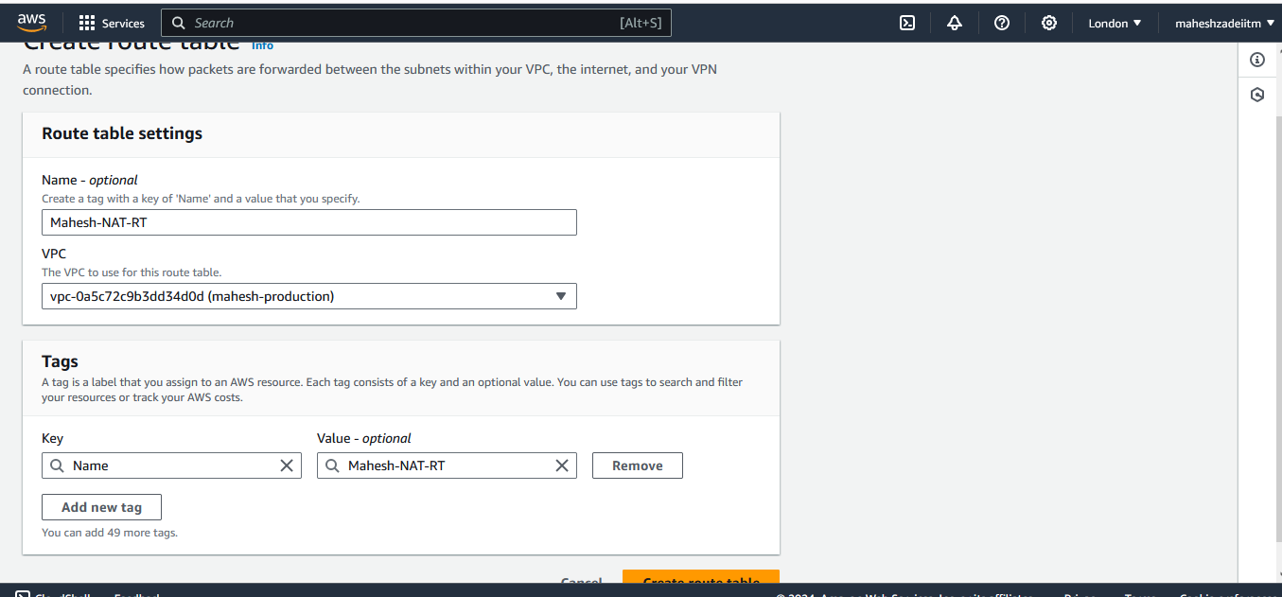

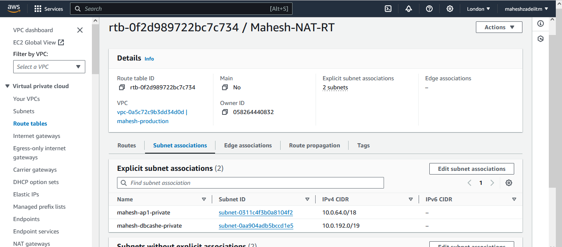

**Crate db RT for private db subnet**

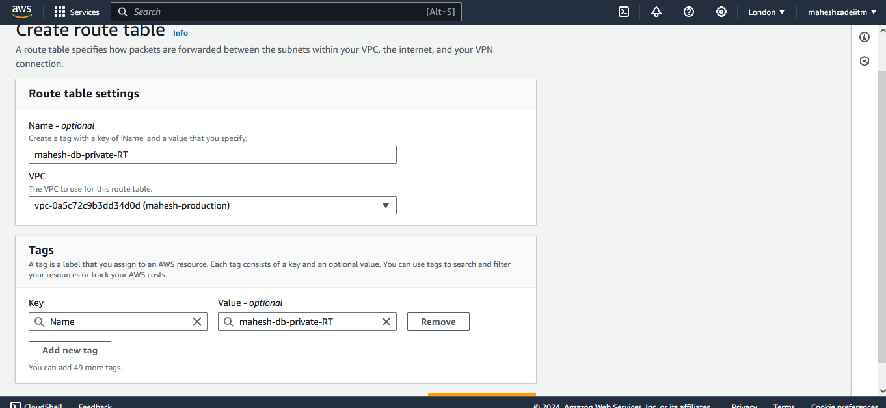

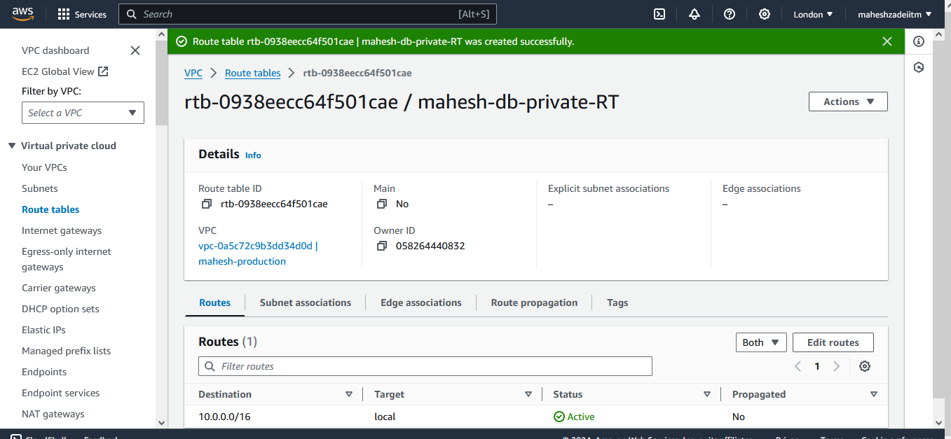

**Edit db-private RT and edit subnet association and save association**

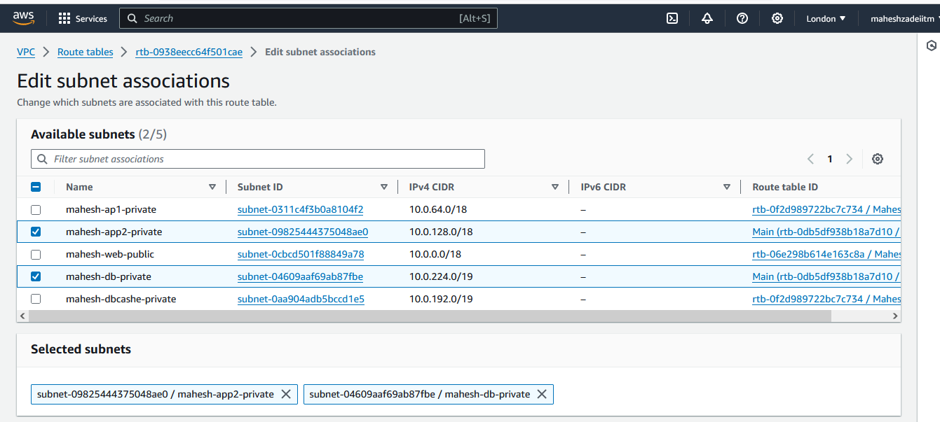

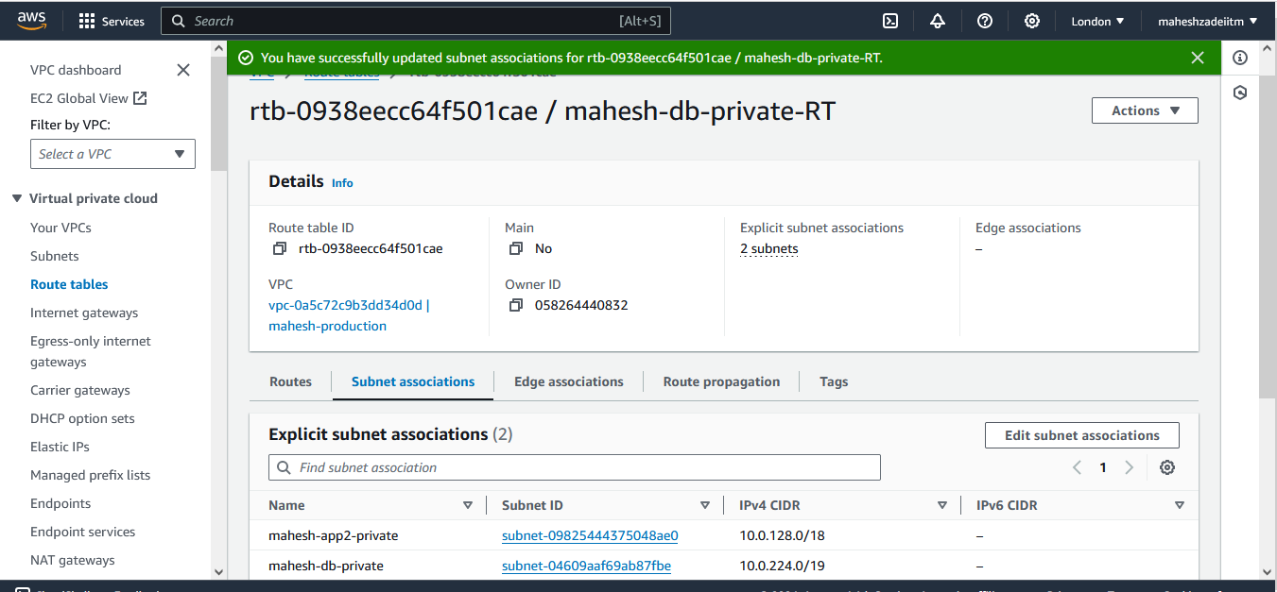

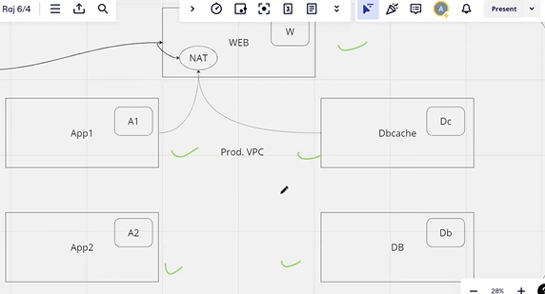

**Now Create the EC2 Instances in each subnet**

3. Launch instances in all subnets and name them as per the subnet that they have been launched in.

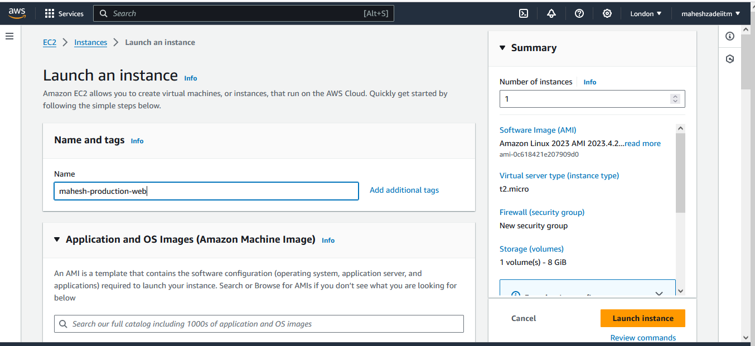

**Select London keypair**

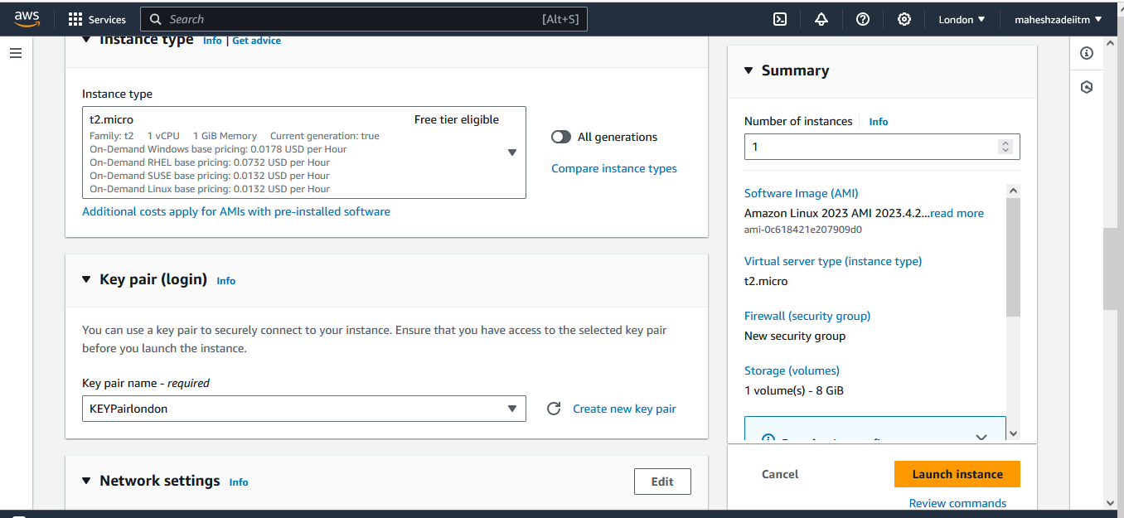

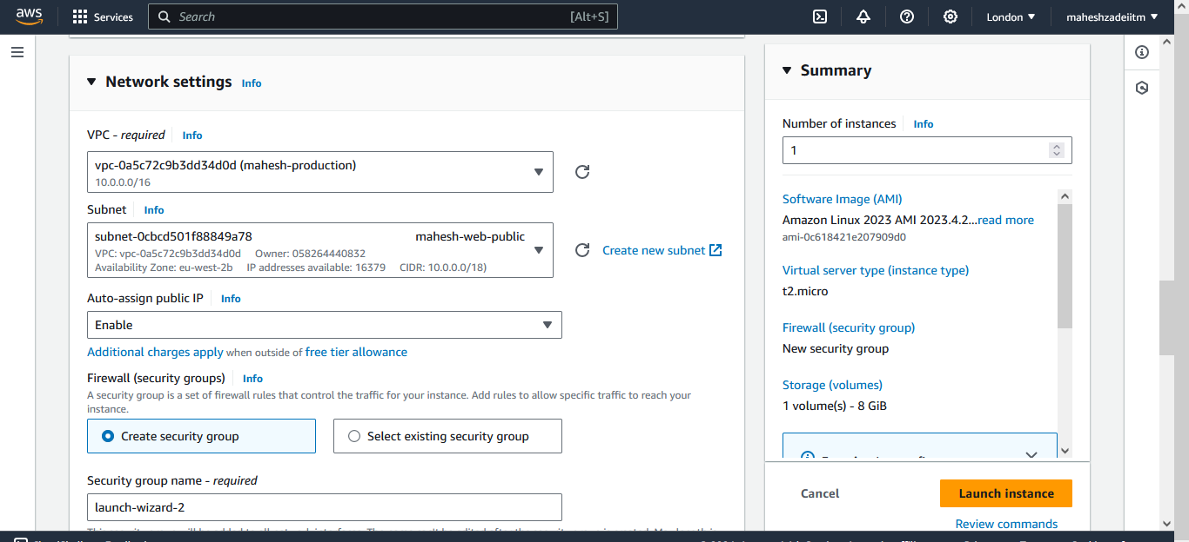

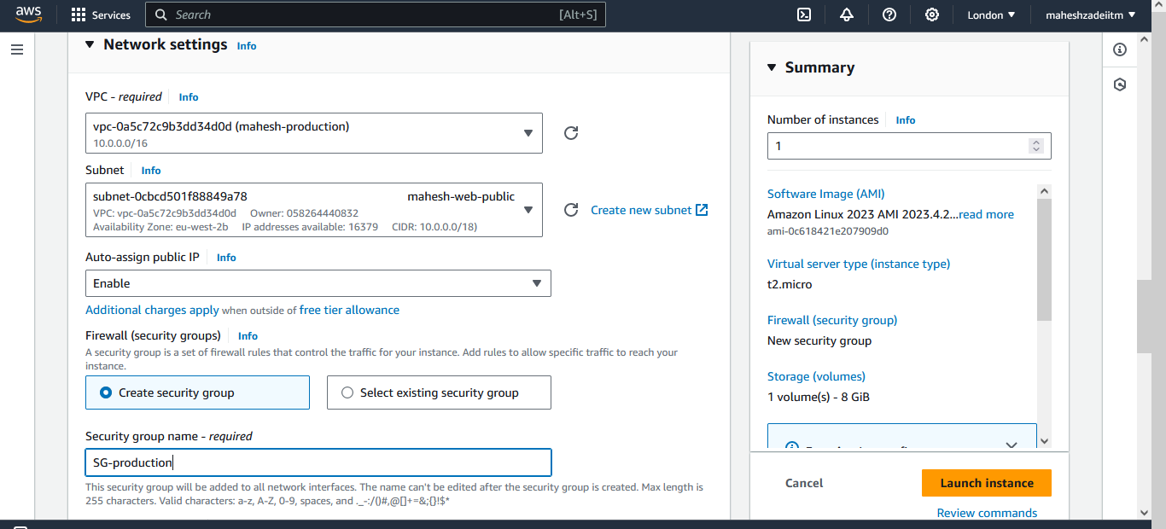

**Enable auto assigned public IPV4 in web subnet**

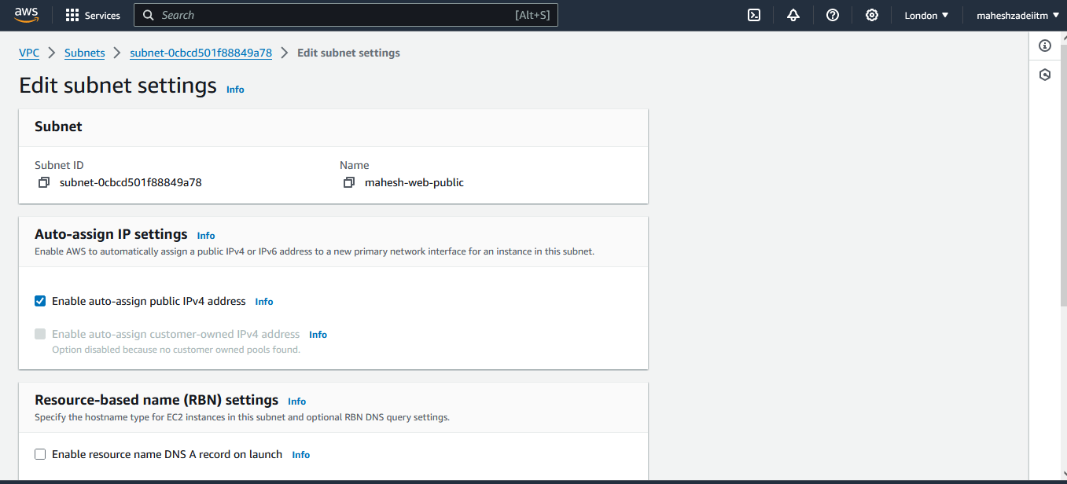

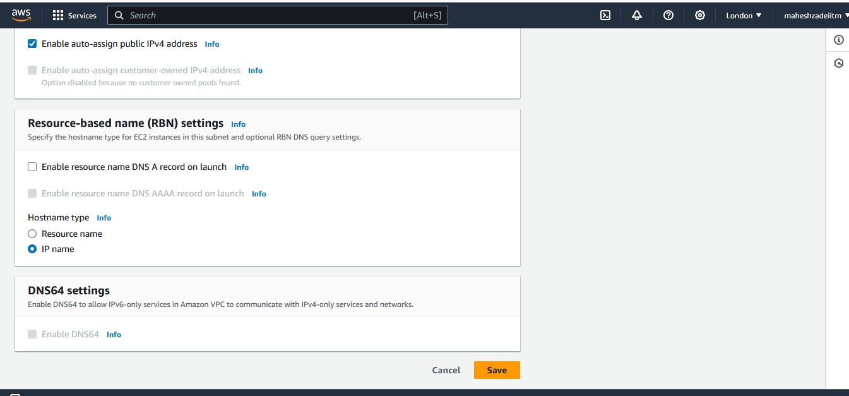

**All the 5 EC2 Instances Launched according to there subnets**

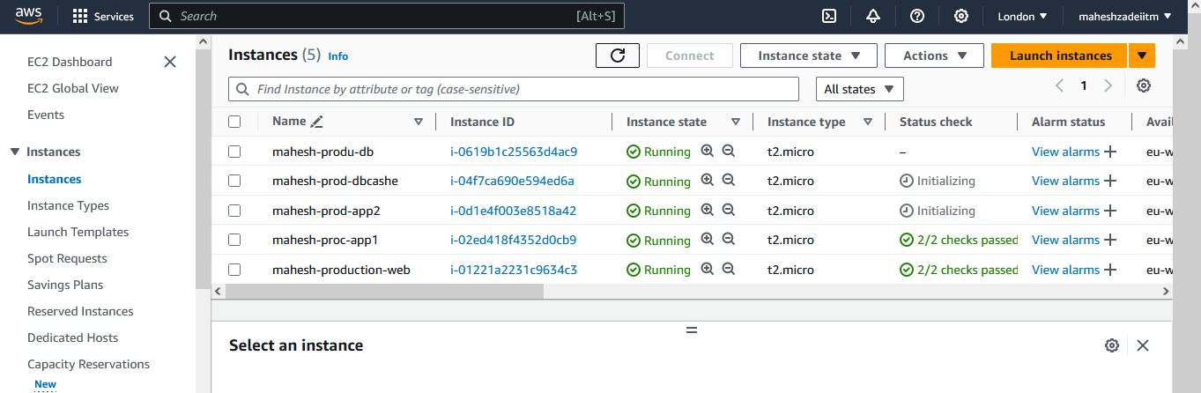

4. Allow dbcache instance and app1 subnet to send internet requests.

Now Launch a NAT gateway for dbcache instance and app1 sunbet to send the internet request.

As per the architecture

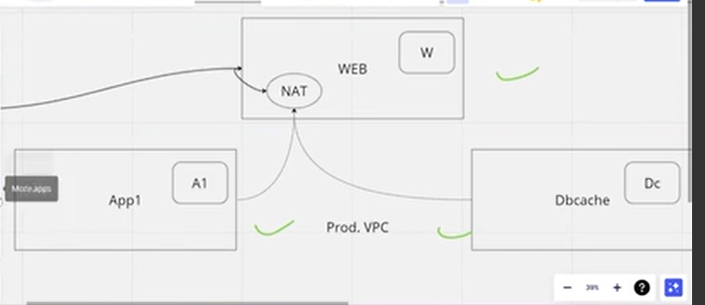

Name the Nat gateway

Select thw Public Subnet web

And assign the elastic IP   
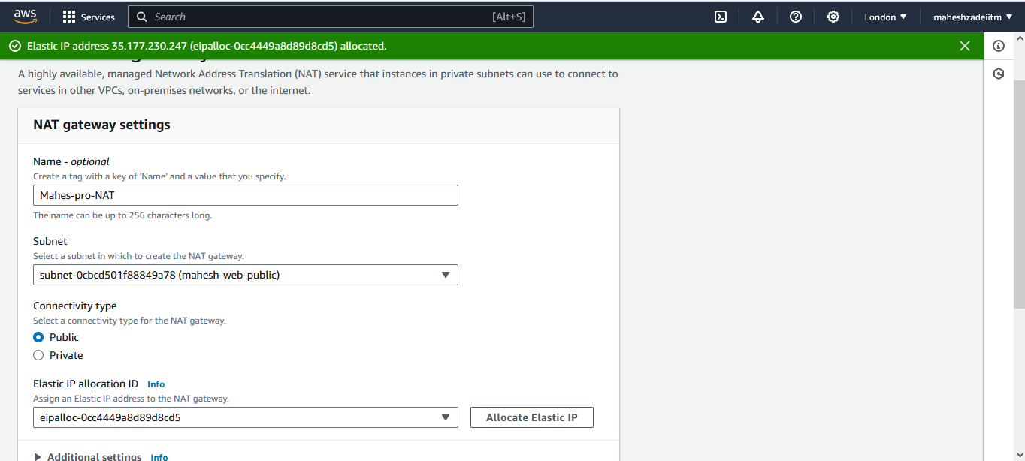

Then click on

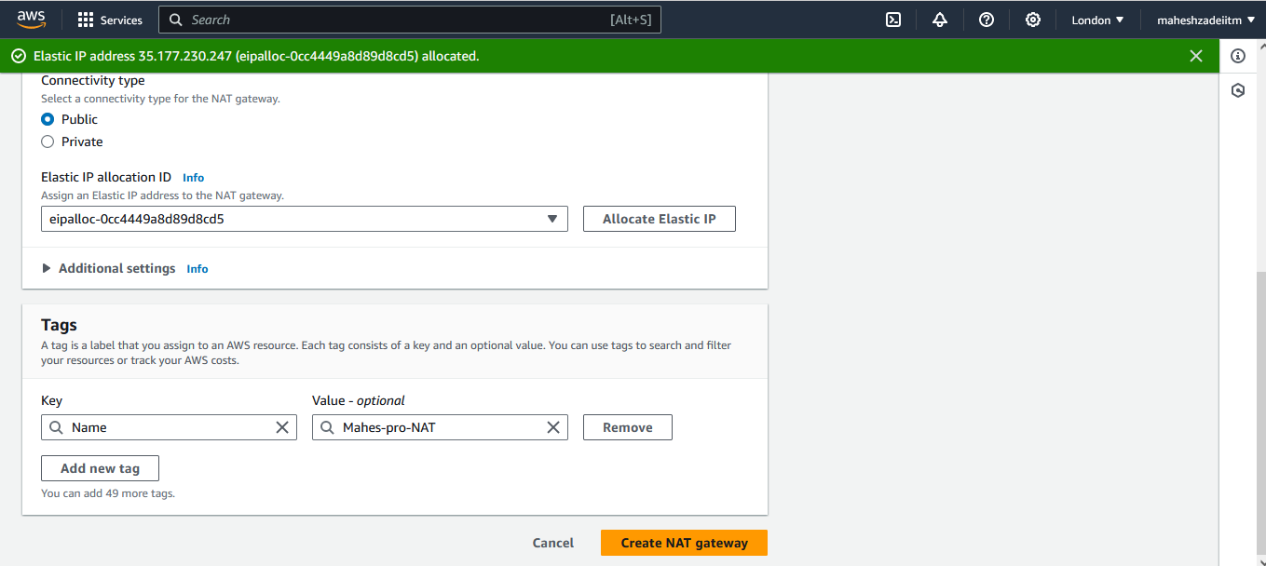

Wait till the Nat Gateway is available state.

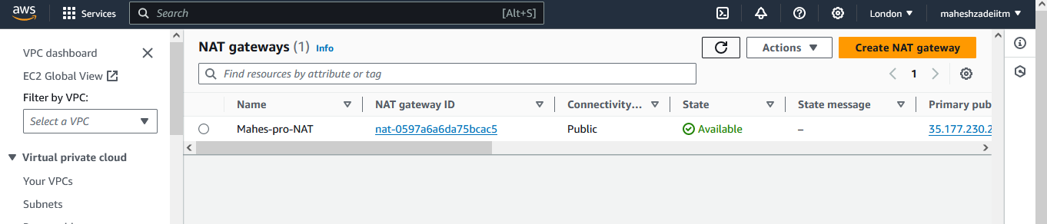

Now Select Nat-RT

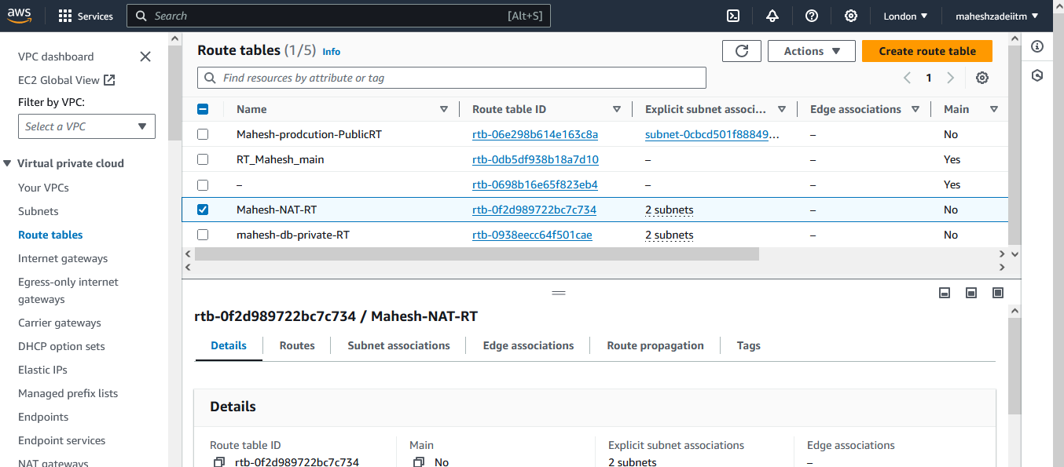

Click on edit Route

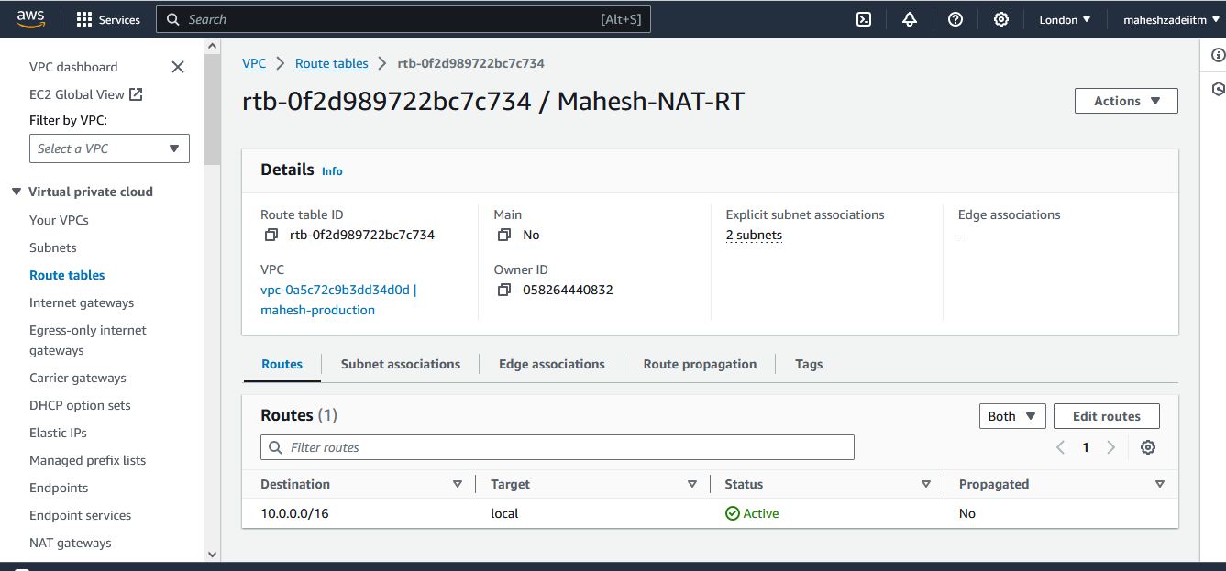

Add route 0.0.0.0/0 and NAT Gateway and save changes

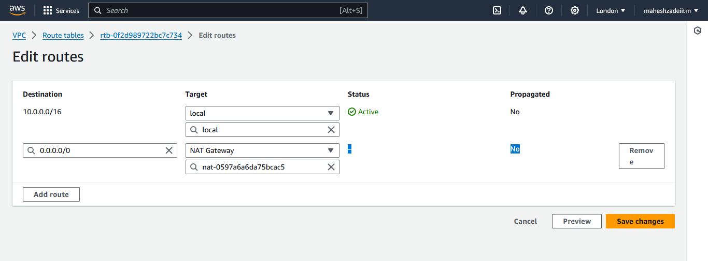

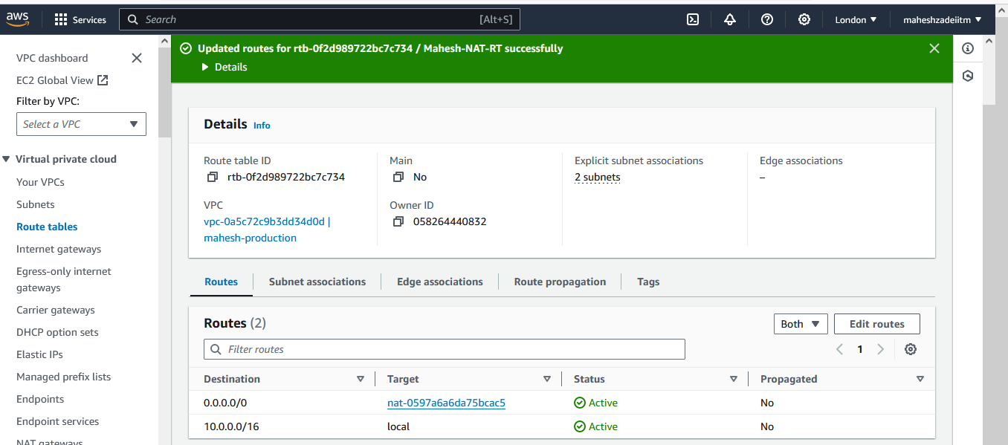

We can not login to the App1 and dbcashe subnet instances ,

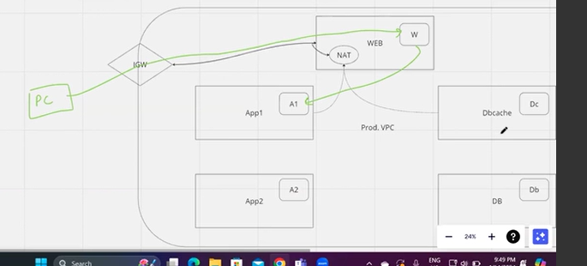

Now we have logged in web instance

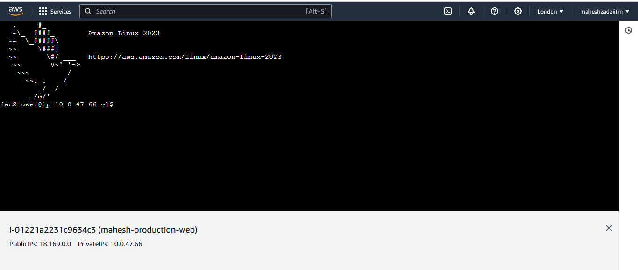

For connecting app1 and dbcashe instance we need to copy the keypair from the London region in to the web EC2 instacne

Copy London keypair content

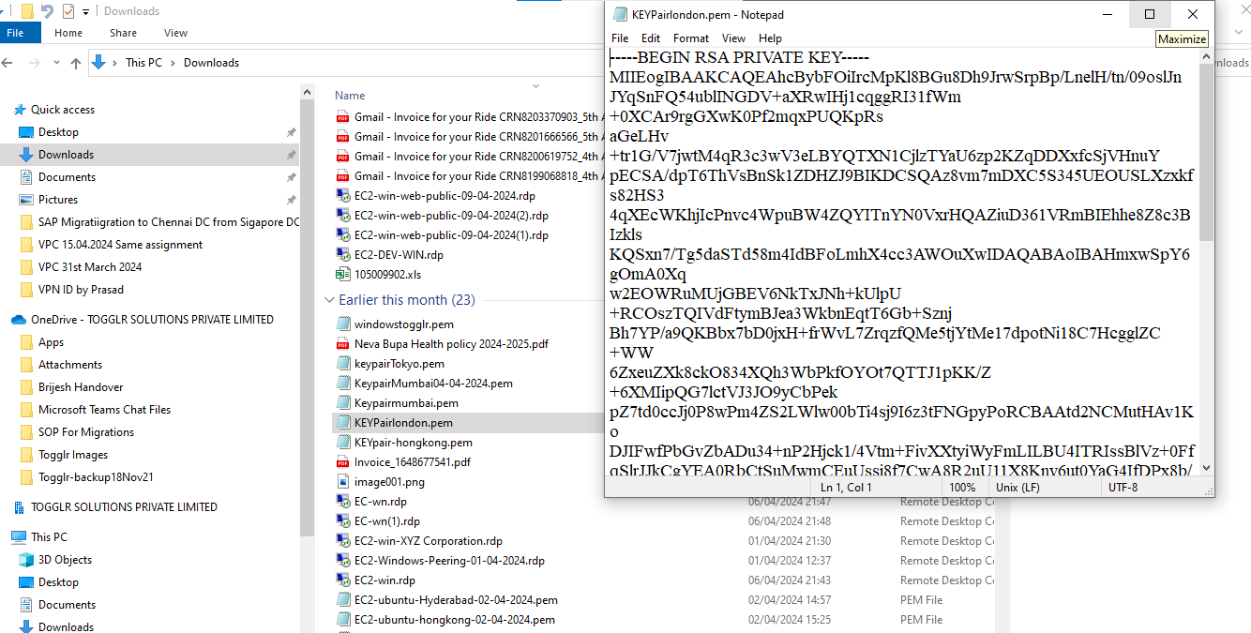

Now go to web EC2 instacne and create keypair file as

Key.pem ( or any name we can give )

Copy the same continent from exiting London .pem file

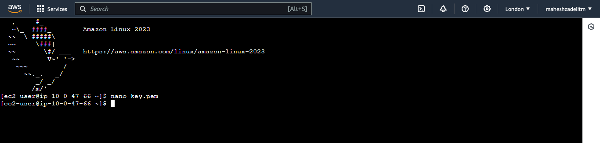

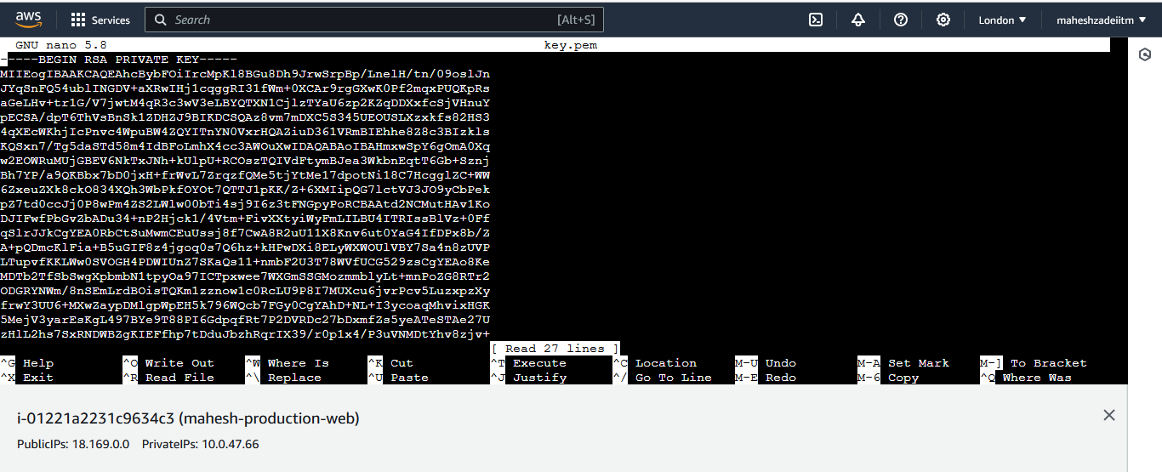

Press CTRL+s to save the file and CTRL+X to exit the file

To check the file created or now pres the command

Cat key.pem

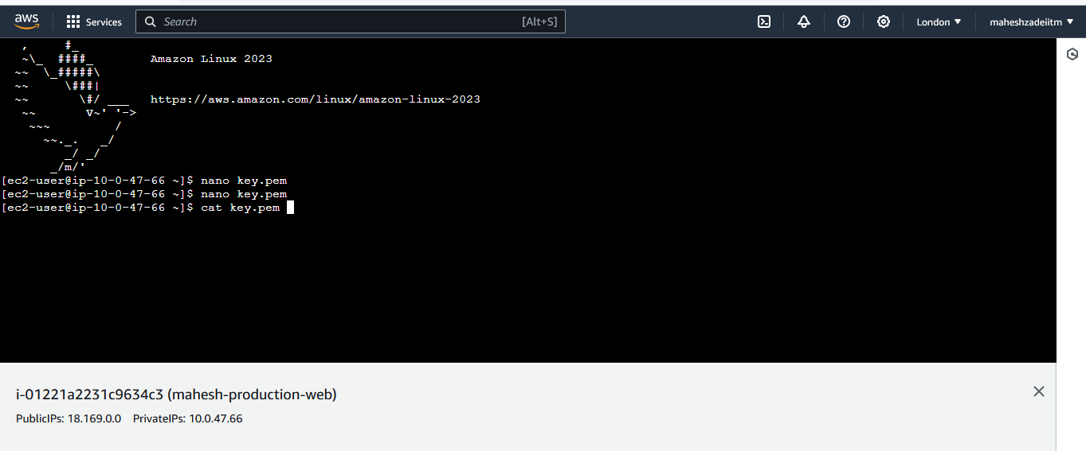

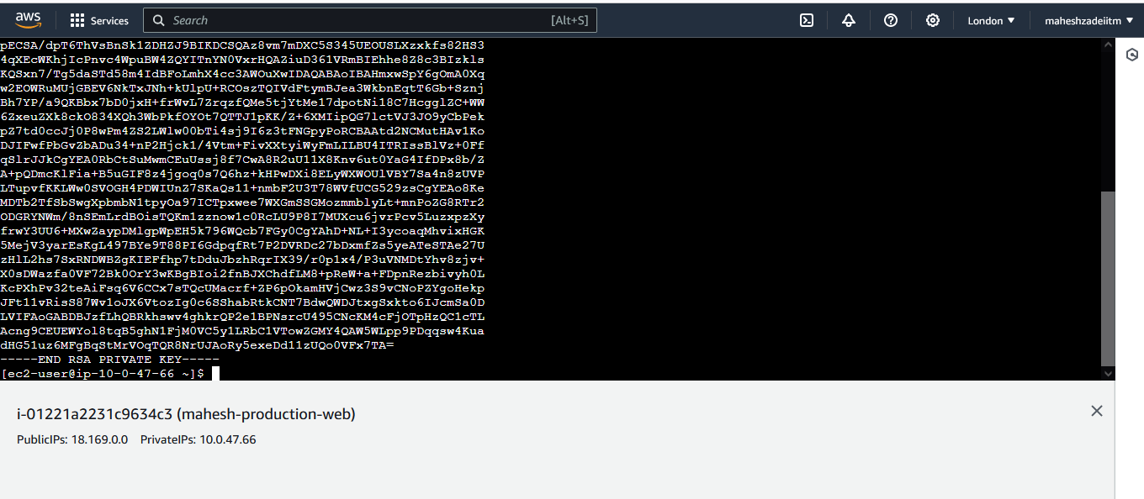

Now run the below command in web server

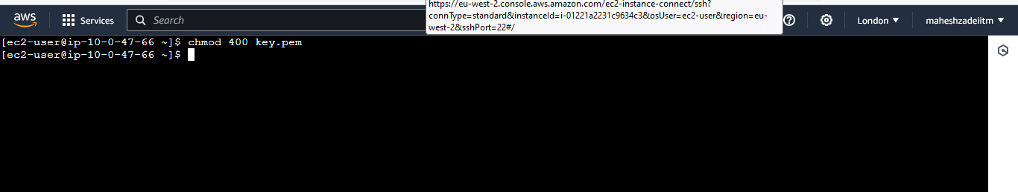

Chmod 400 key.pem

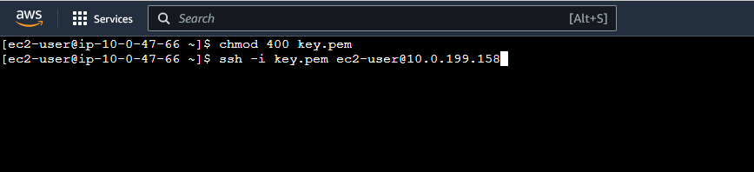

Copy private IP od DBcashe instance and paste in the command below.

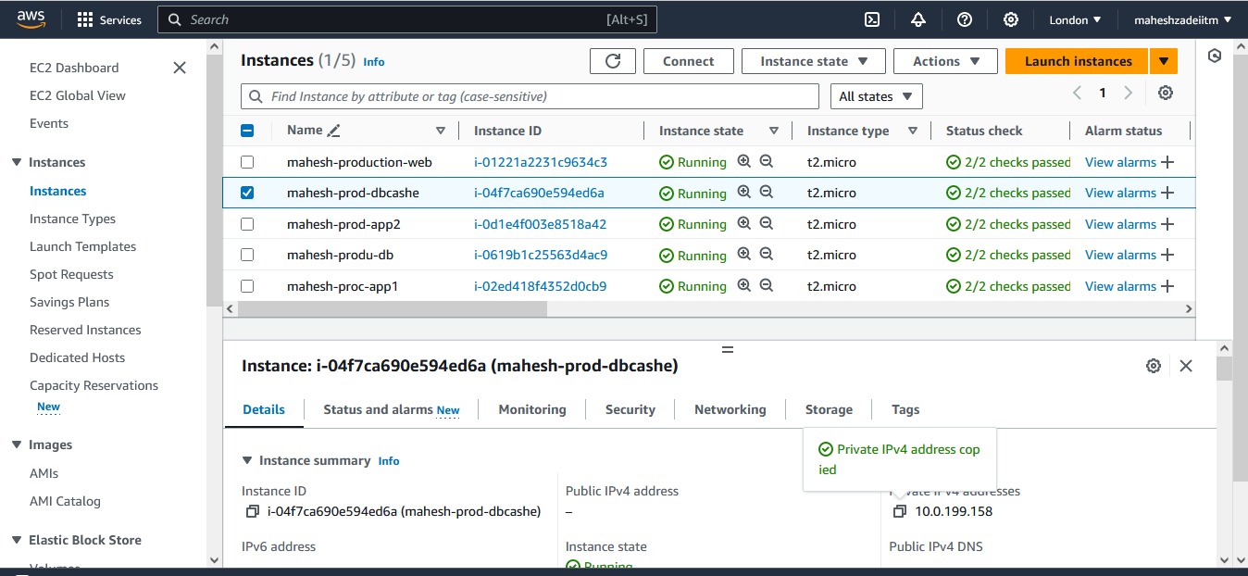



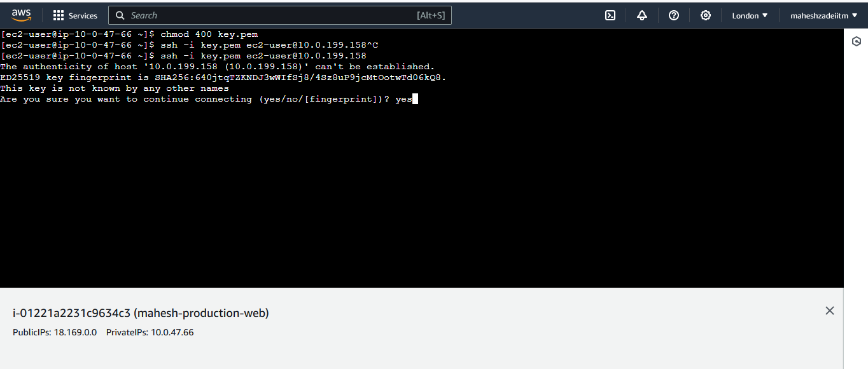

Press yes

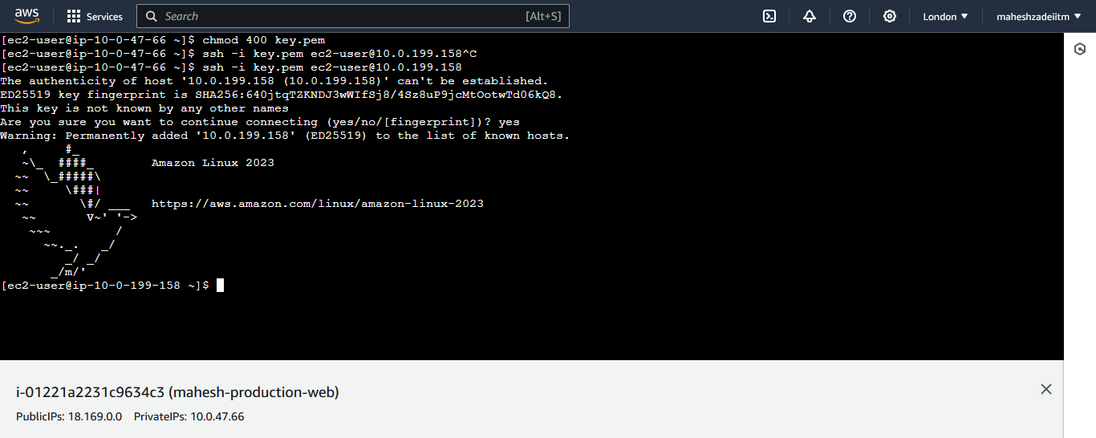

Now connected to dbcashe instance

Now check for app1 subnet instance

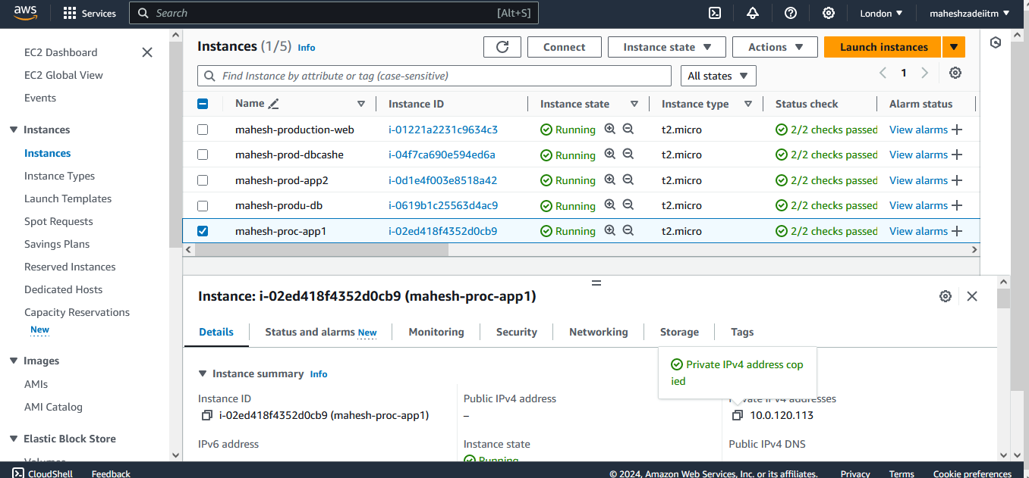

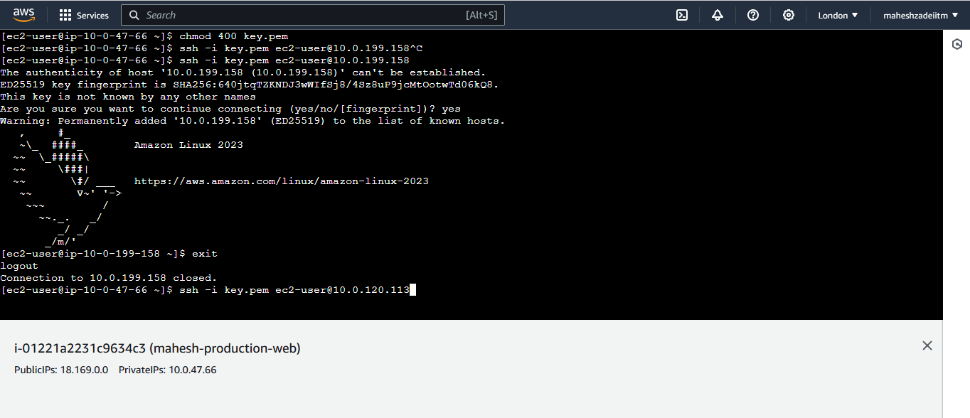

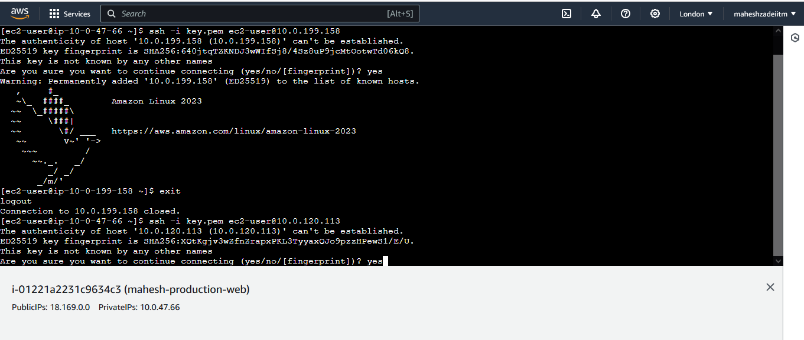

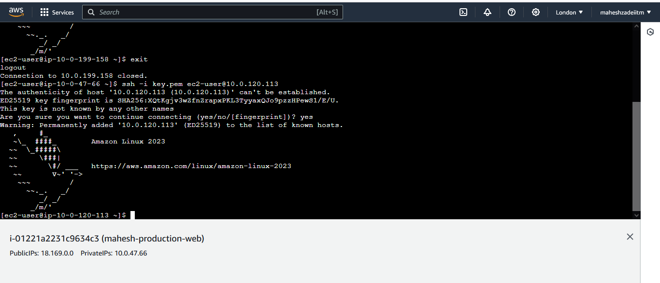

Now also app1 subnet instance connected via private subnet instance

Through NAT Gateway.

To check internet is working in private subnet

Type the command ping google.com

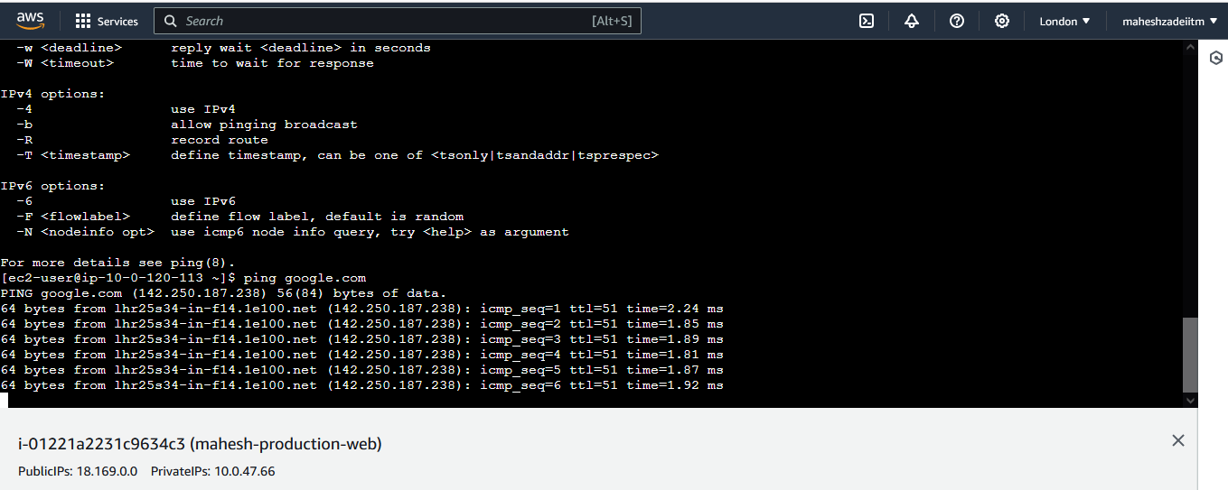

Also you can check by the command EC 2 is updating or not by the command

Sudo yum update

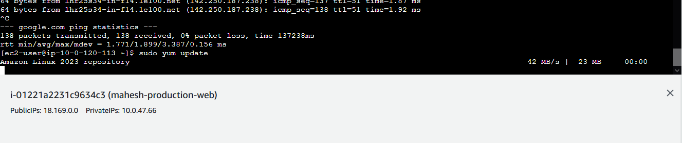

Now check appe private IP that system is updating or not

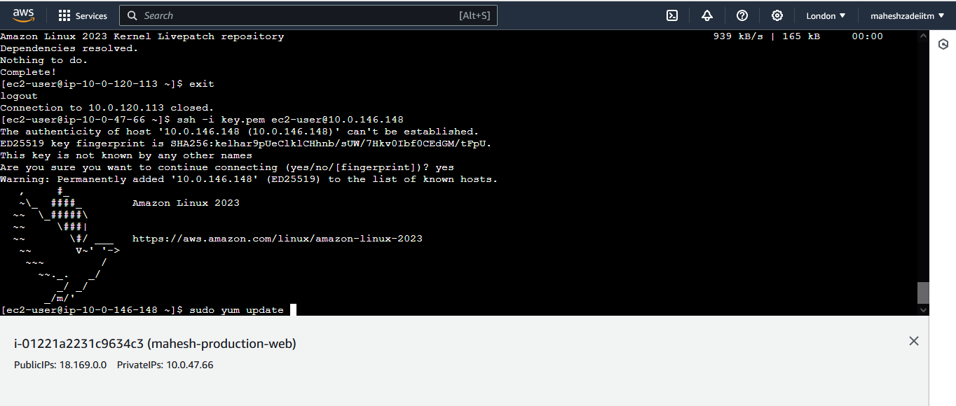

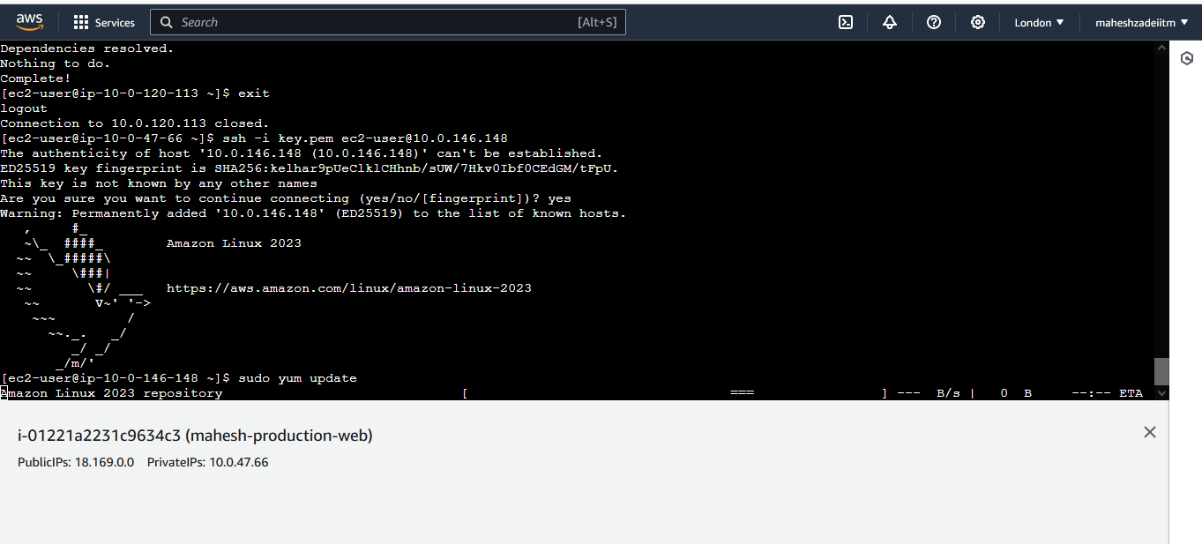

Its not updating system as don’t have internet connectivity.

5. Manage security groups works on EC2 and it only allows traffic Level and NACLs works on subnet level and it allows and deny traffic.

Security groups are working in stateful and NACL work on stateless

**Development Network:**

1. Design and build 2-tier architecture with two subnets named web and db

and launch instances in both subnets and name them as per the subnet

names.

1. Make sure only the web subnet can send internet requests.

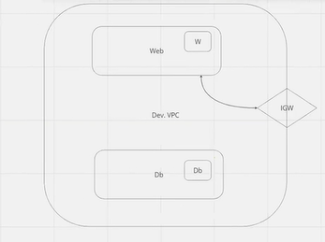

3. Create peering connection between production network and development network.

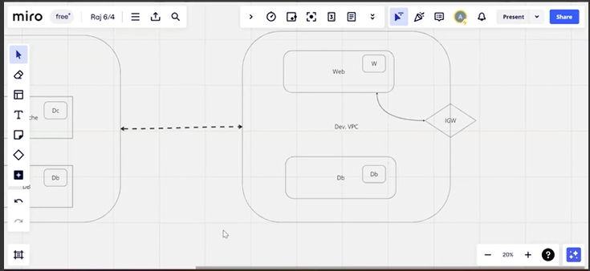

4. Setup connection between db subnets of both production network and development network respectively.

**Pls add the ICMP protocol in both db subnets to get the db connectivity.**

**Now Go to VPC and Create VPC for the Development Network**

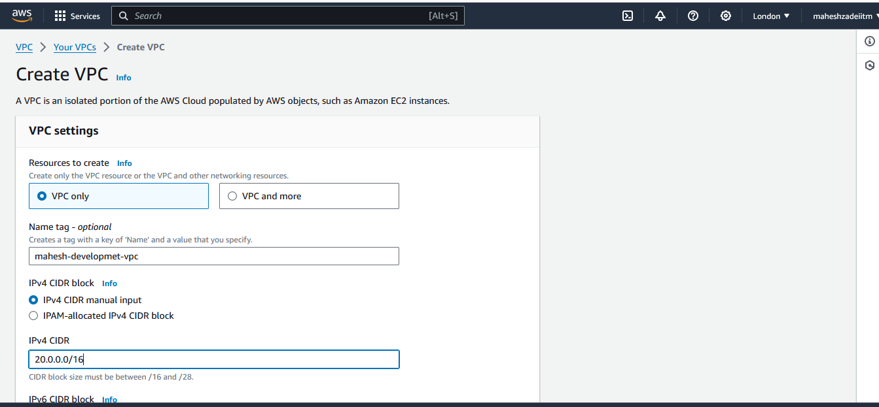

**Give the CIDR as 20.0.0.0/16**

**And dive it in 4 subnets as per below**

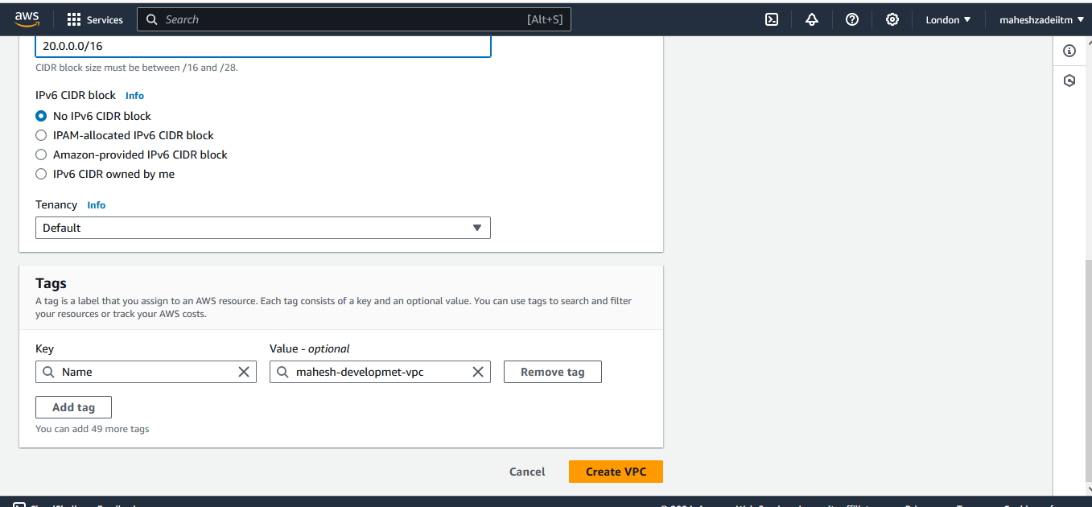

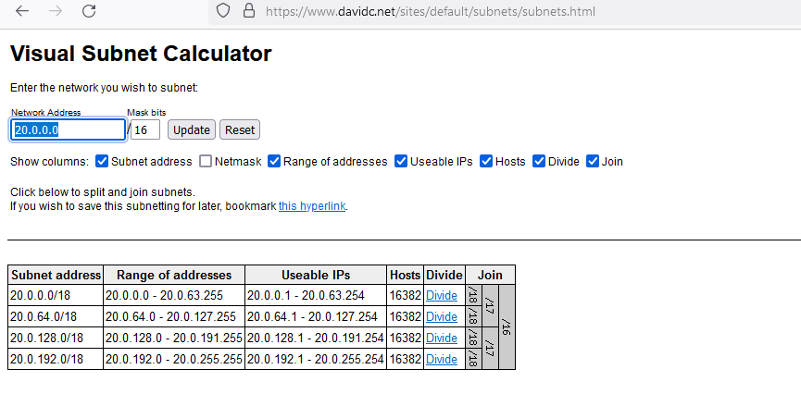

**User different CIDR for the peering connection to to avoid overlapping**

**Now go to subnet and create web public subnet and db private subnet**

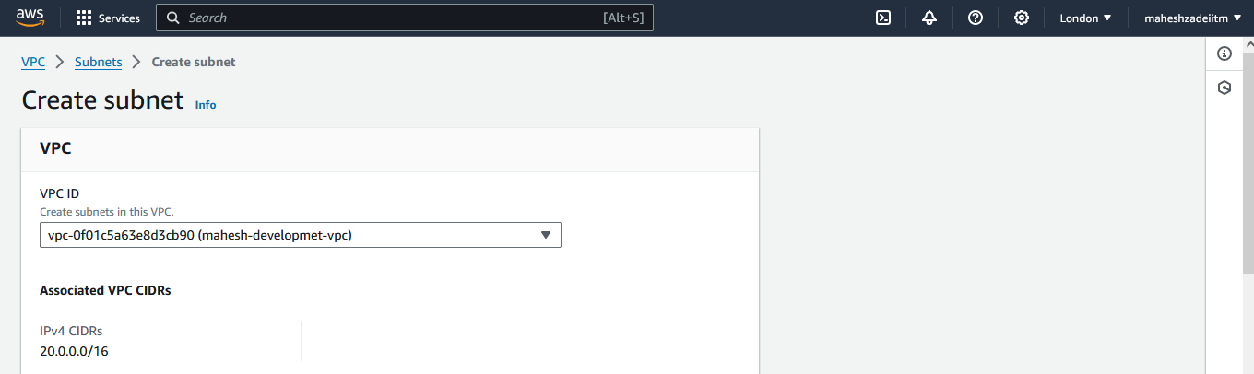

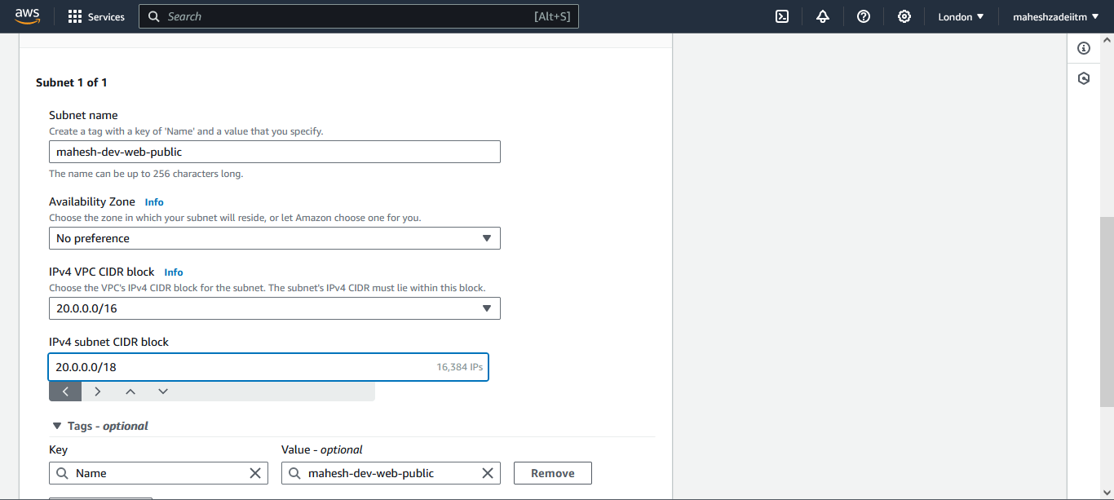

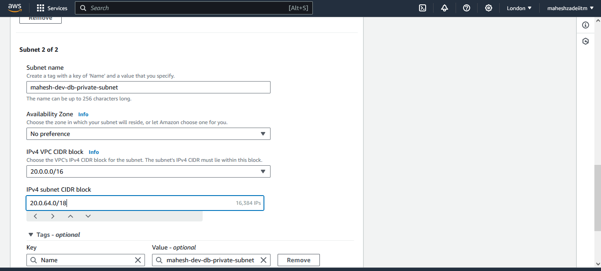

**Both Subnets are created**

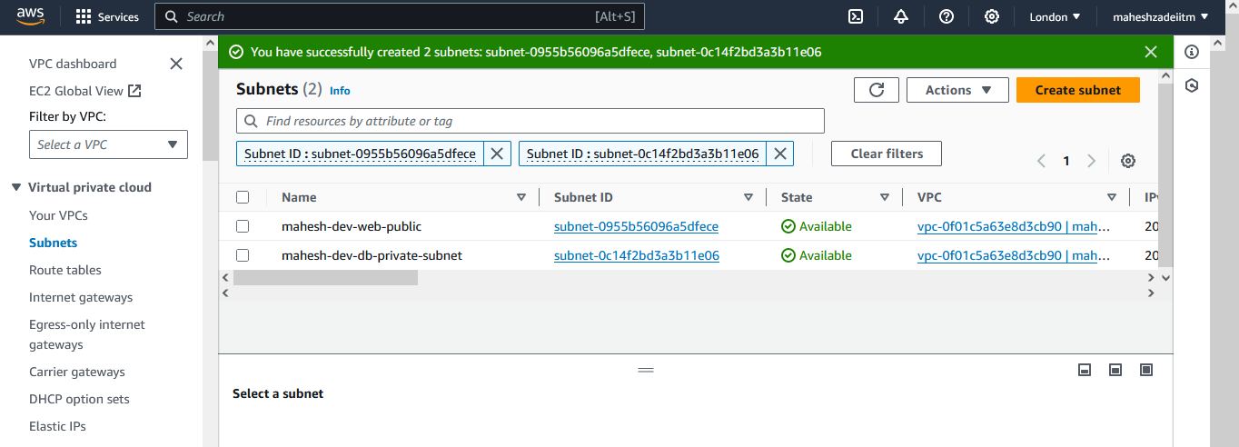

**Now create the Internet gateway**

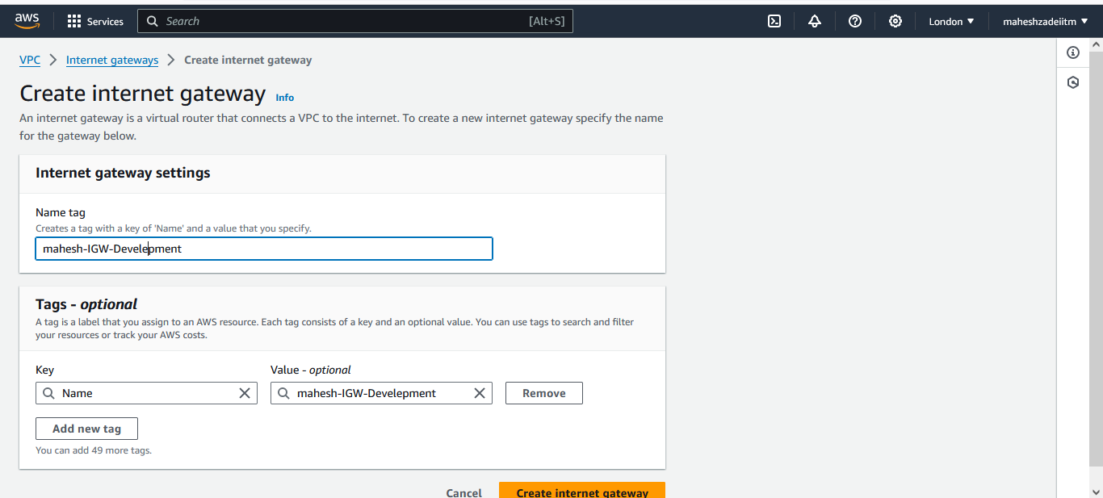

**Now attach it to DEV VPC  
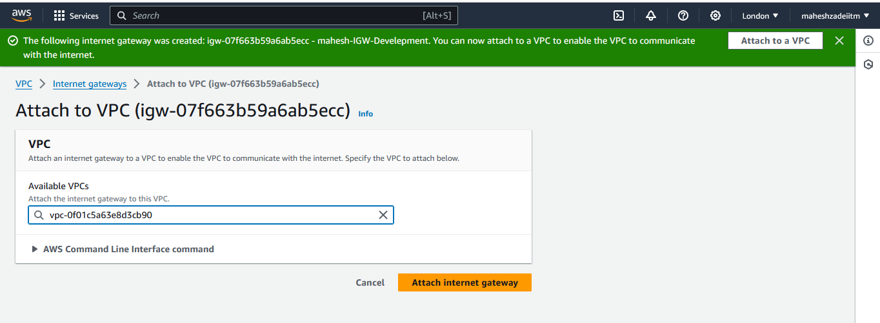**

**Now we need to create the two Route table one for web and one for db private subnet**

**Web RT**

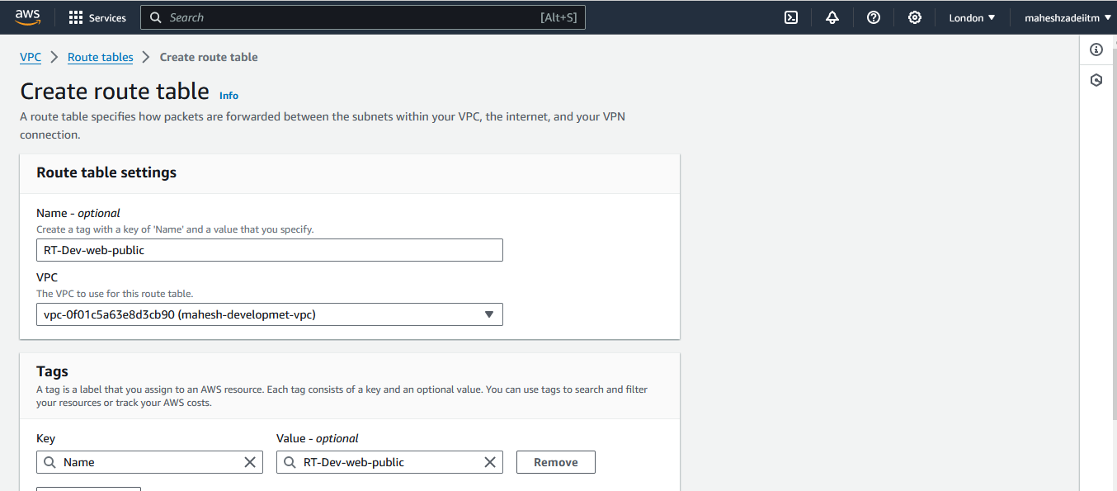

**DB RT**

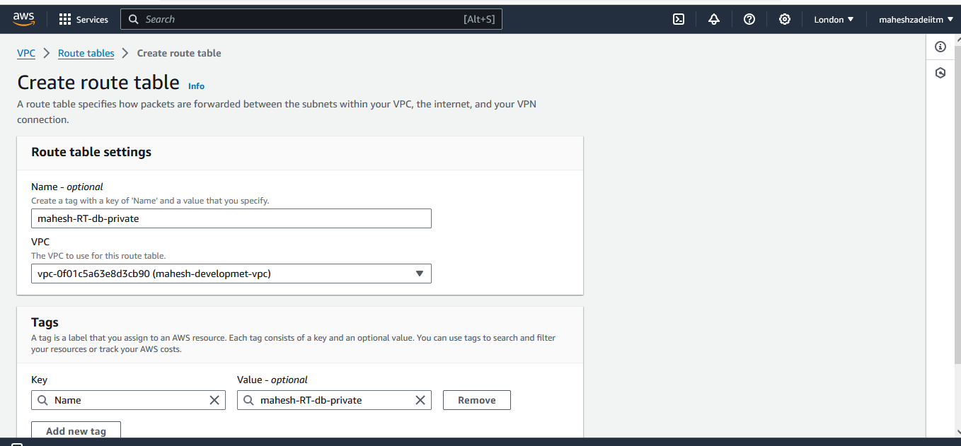

**Now go to web RT**

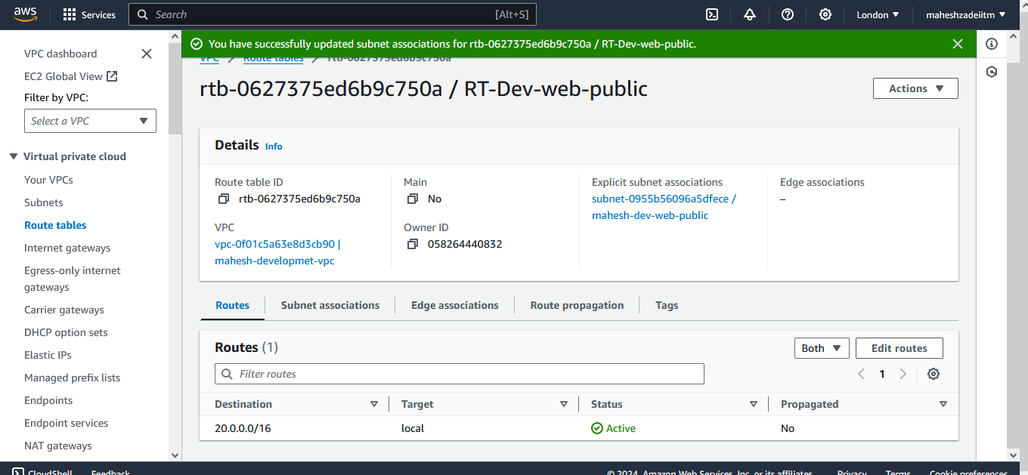

**Edit subnet association**

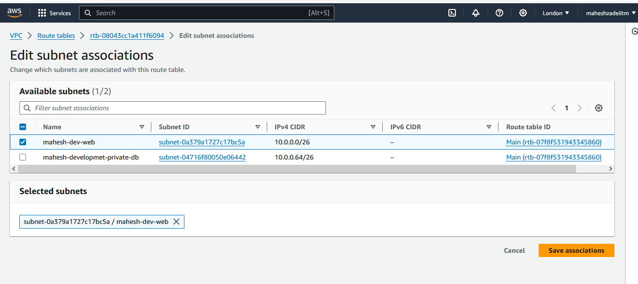

**Save association**

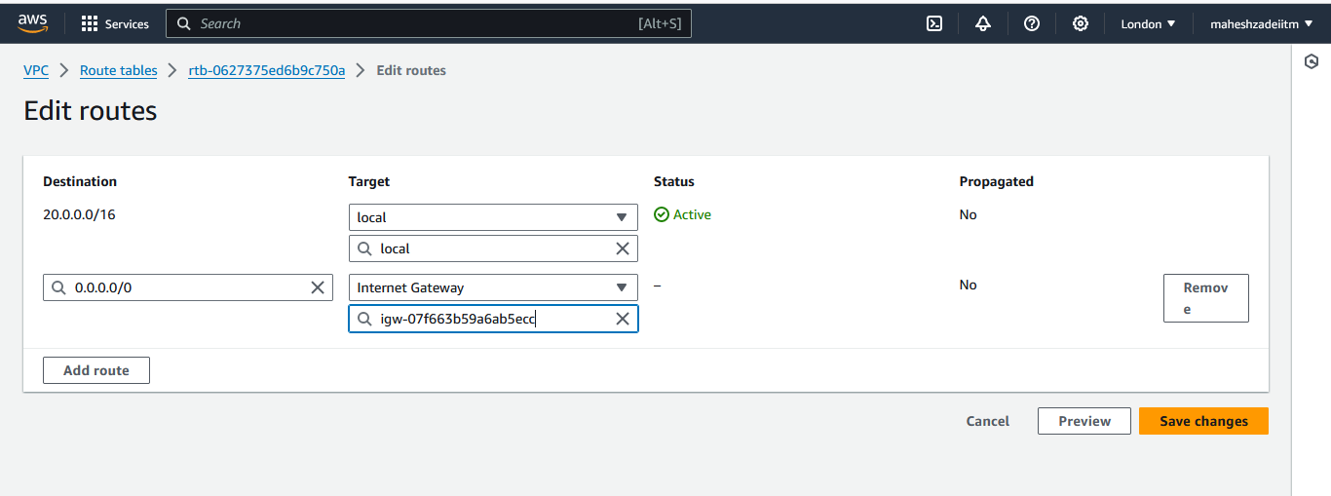

**Now go to edit route**

**Save changes for the internet connection**

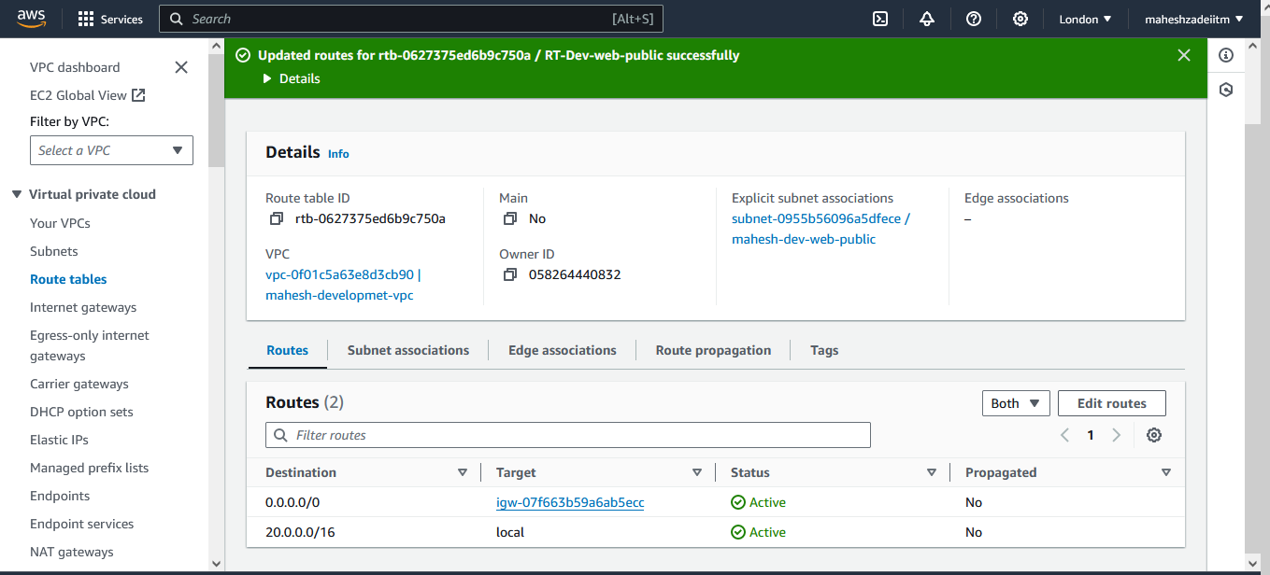

**Now Lauch the two EC2 Instacne in web and db subnet of Dev VPC   
Launch the web instance**

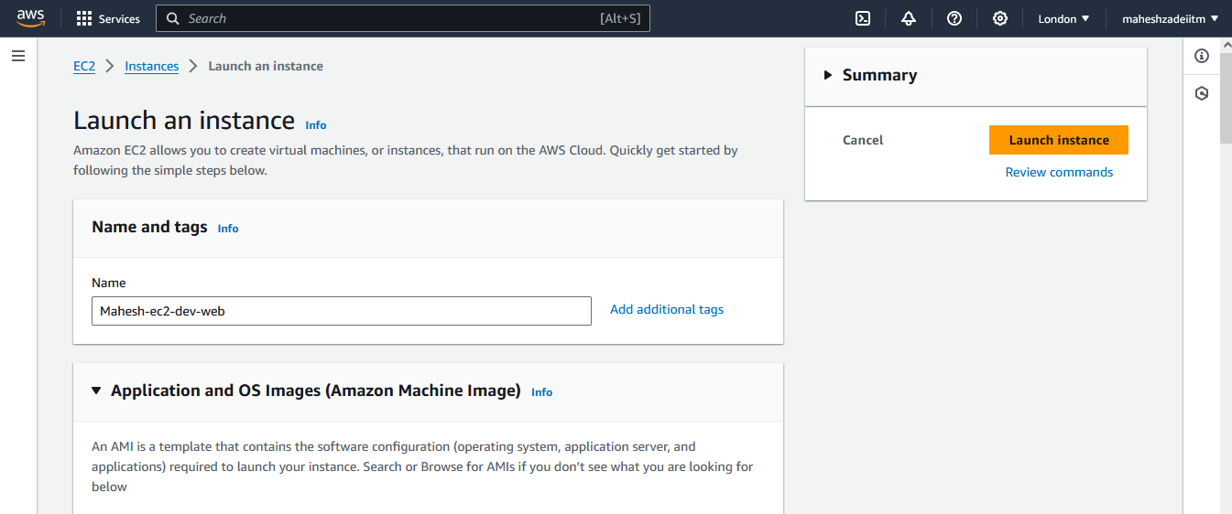 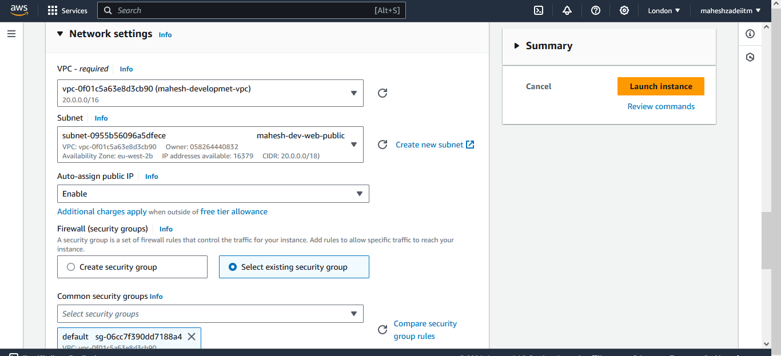

Go to Setwork setting and select the Dev VPC and web public subnet and assign the public IP

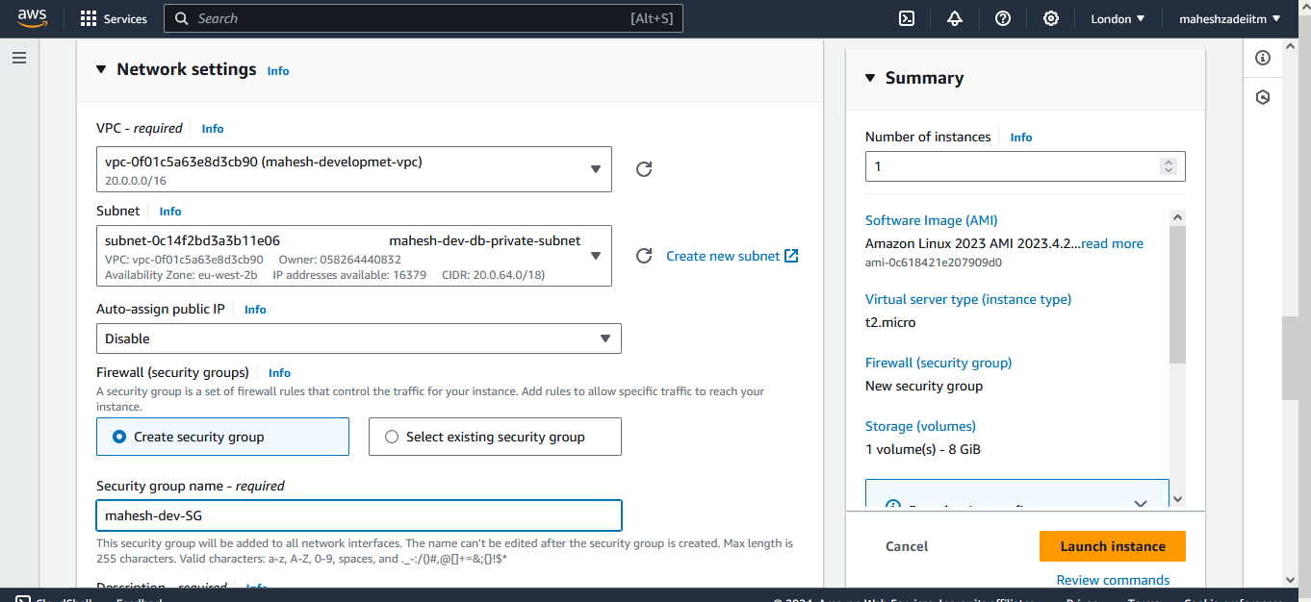

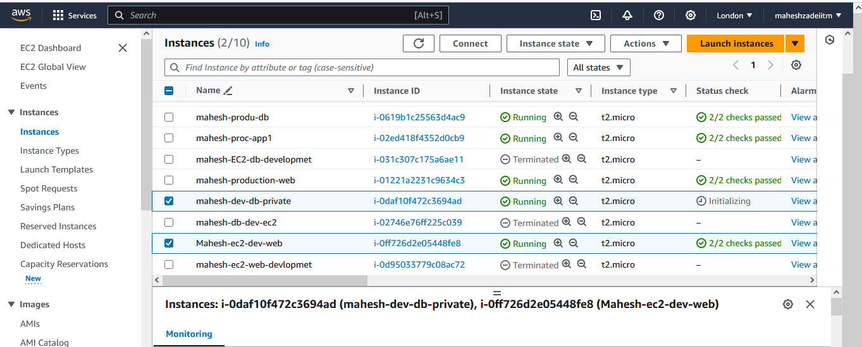

**Two instances are launched in Devlopmnet VPC**

**Now go to peering connection**

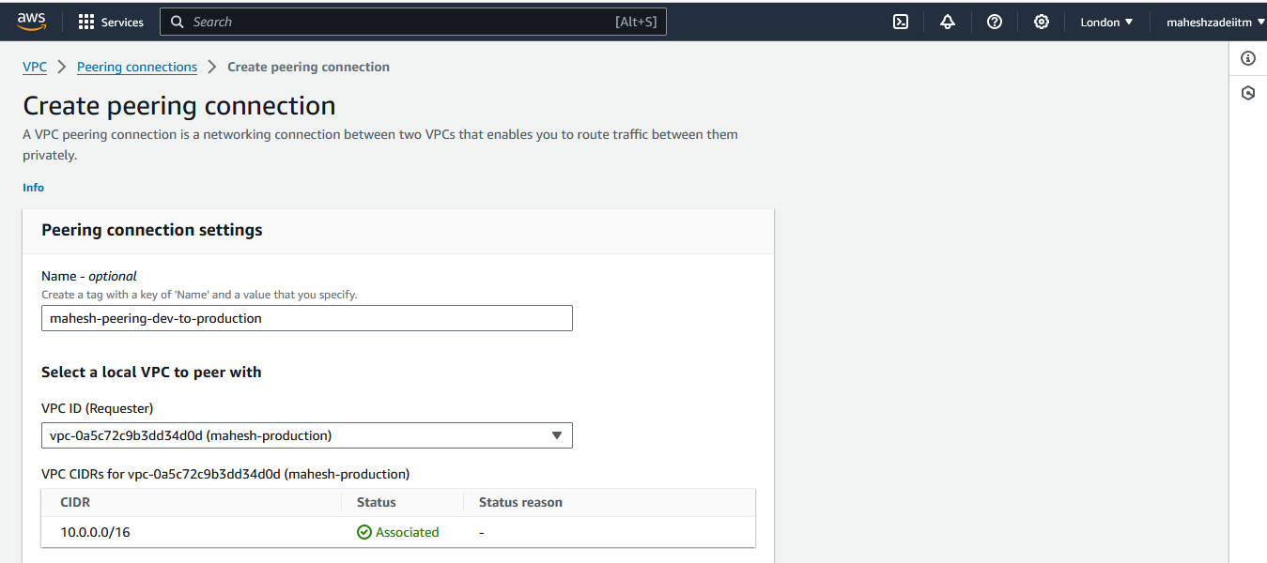

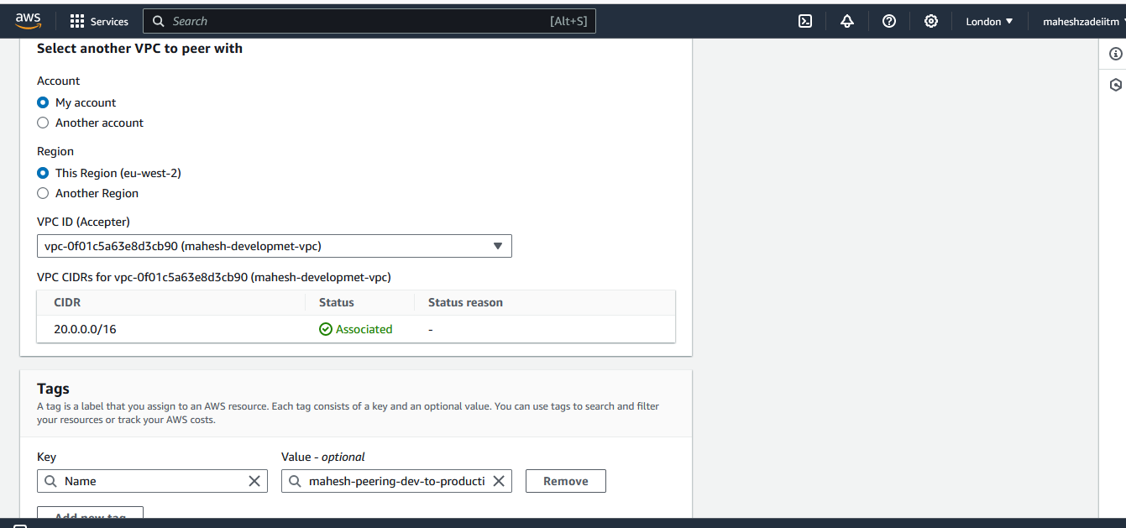

**Click on peering connection**

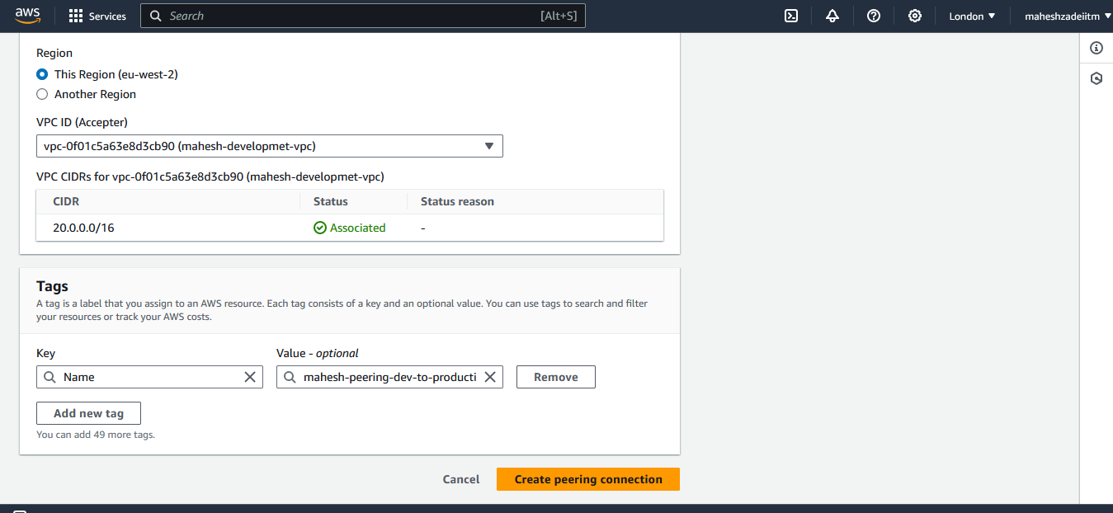

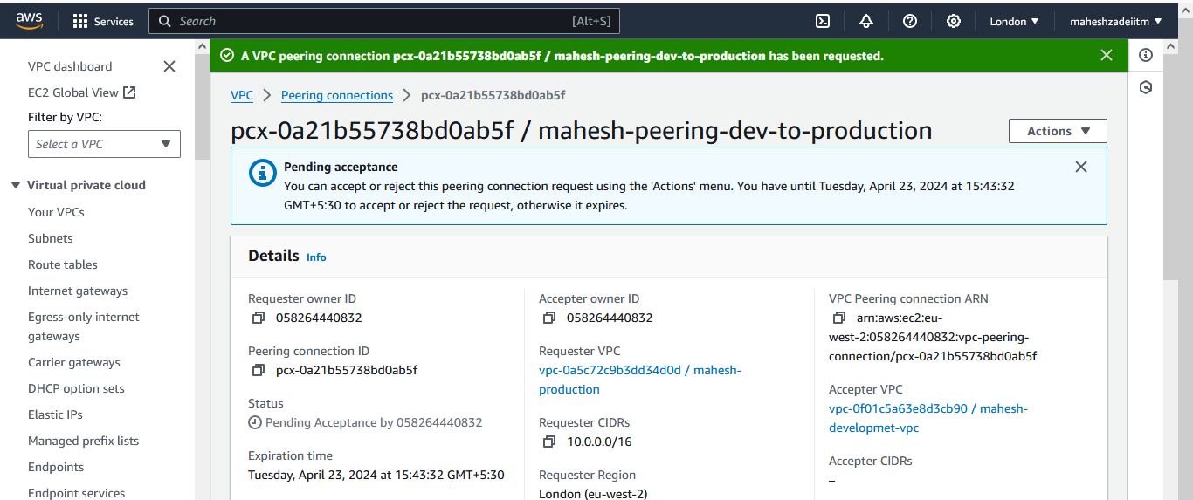

**Peering connection has been requested**

**Now go to action and accep the request**

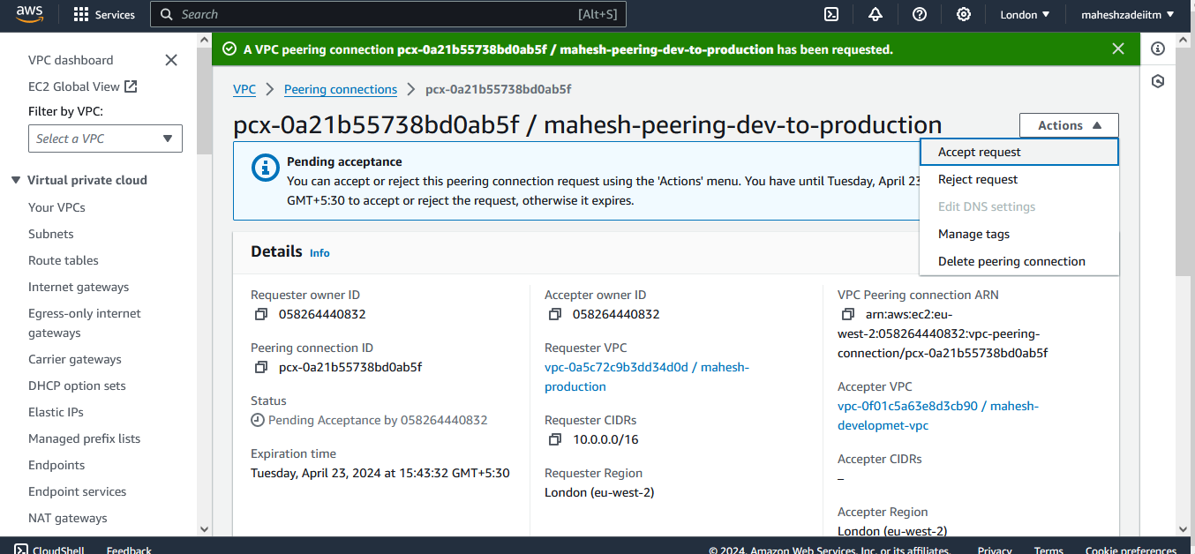

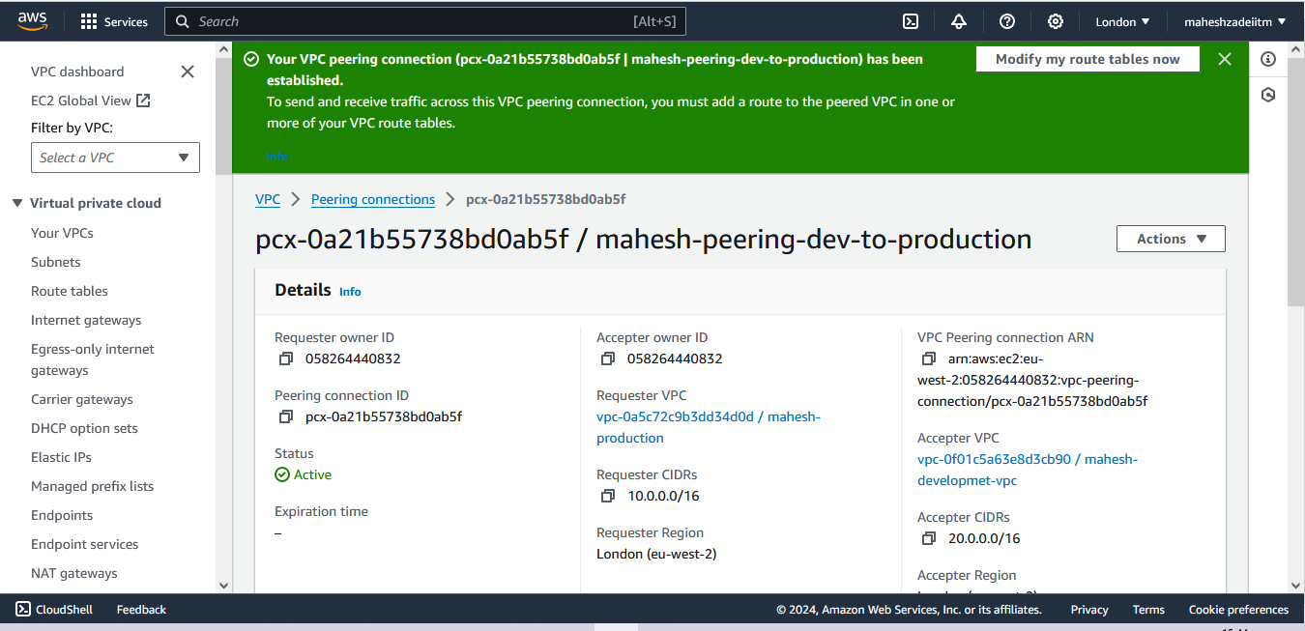

Your VPC peering connection (pcx-0a21b55738bd0ab5f | mahesh-peering-dev-to-production) has been established.

To send and receive traffic across this VPC peering connection, you must add a route to the peered VPC in one or more of your VPC route tables.

Now go to private RT of production VPC

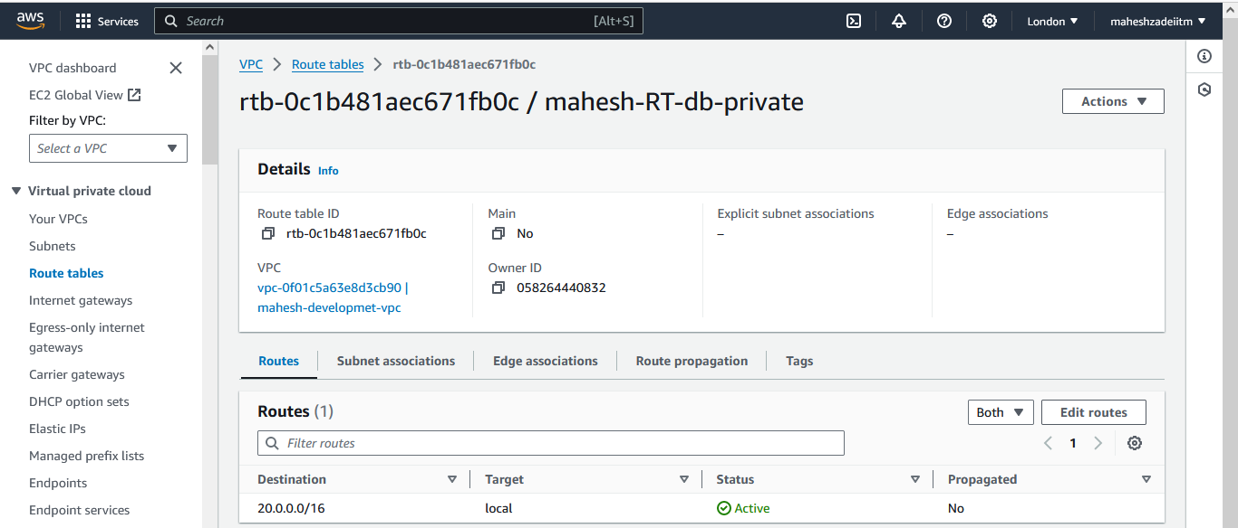

Go to dev priate subnet and take the CIDR and go to Route table and add the CIDR and perring the connection only between the two private subnets

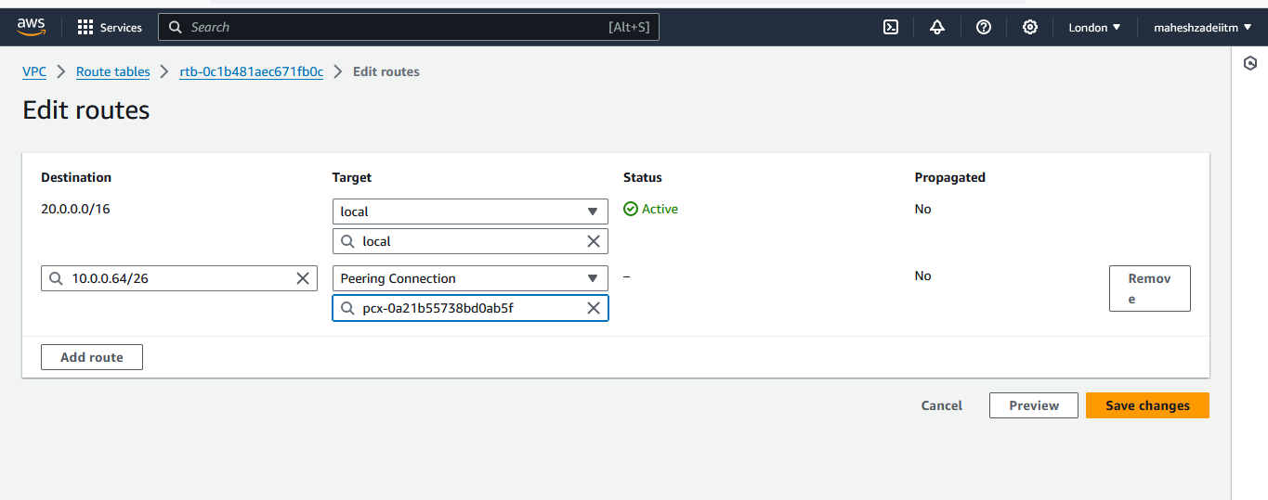

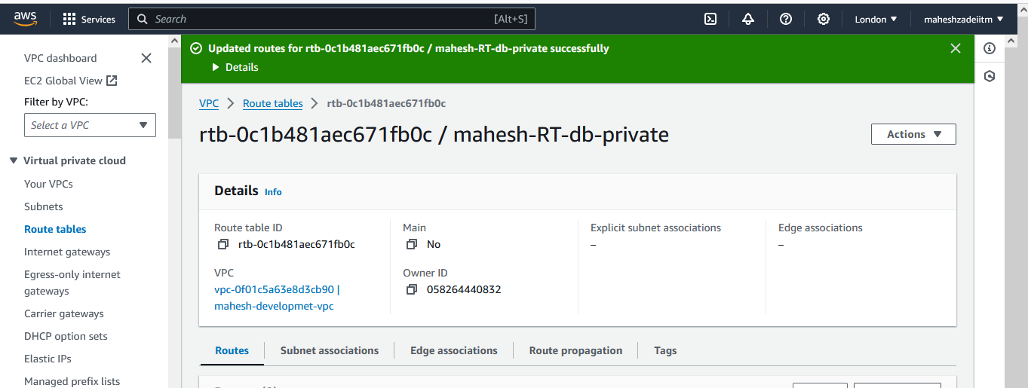

**Similarly repeat the process for development private RT**

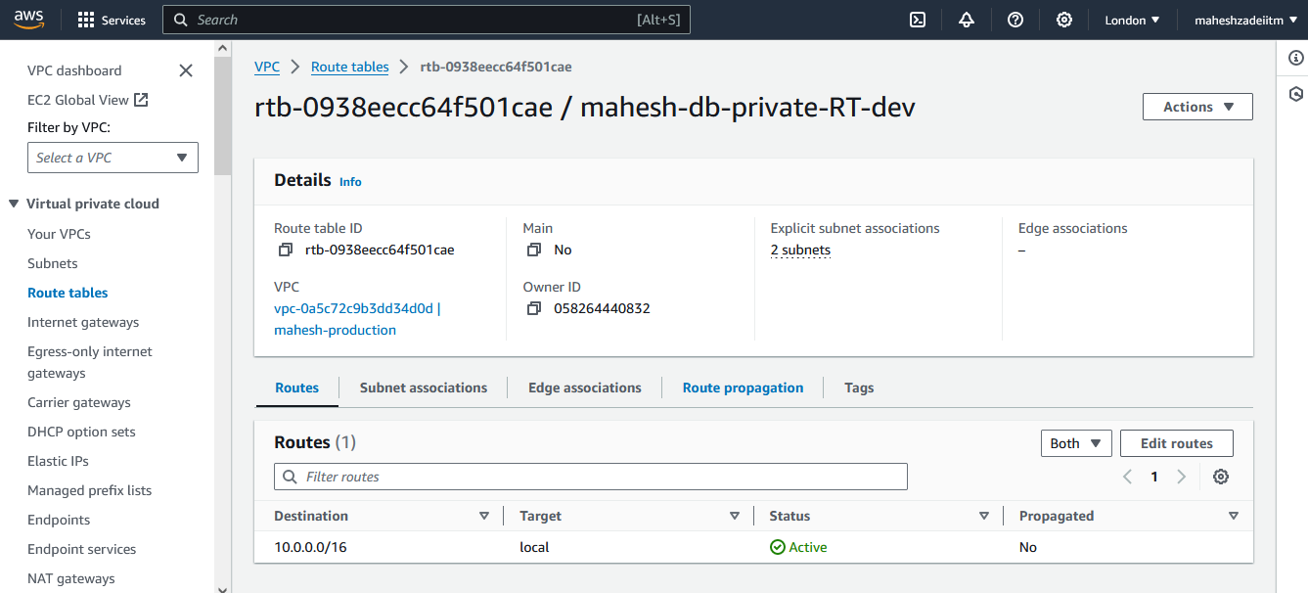

**Edit route**

**Go to production subnet route table and copy the CIDR**

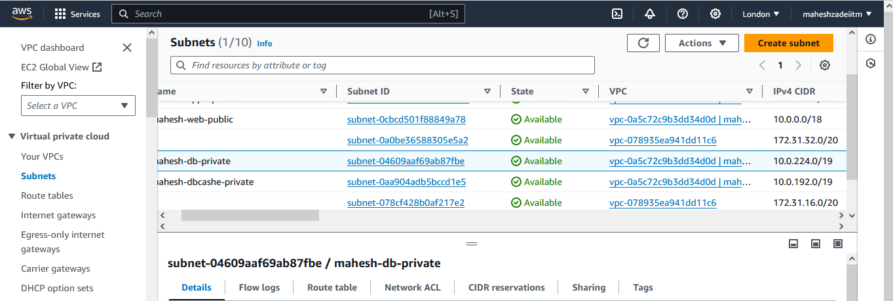

**Copy the CIDR** 10.0.224.0/19

**10.0.0.0/16 prod CIDR**

**20.0.0.0/16 dev CIDR**